IE4727 Web Application Design - Project Report

Design project group number: F36-DG06

Team members: OMAR BIN SHEIK MUSTAFA, LINCOLN HOE

Project Title: A web portal for online appointment of dental clinic visit

Summary of Project: Our project seeks to create a dental clinic website that allows potential clients to view the available list of doctors, their backgrounds and our services. Simultaneously, we will also create a booking system to allow clients to book their desired appointment slot with a doctor of their choice. The booking system will also allow for clients to reschedule appointments as well as letting doctors set their own available clinic hours for booking or reschedule client appointment.

Table of Contents

1. Application Requirements and Specifications3

2. Functional Requirements and Specifications3

3. Design of the web application4-9

Site Map4

Storyboard5

Wireframe6-9

Database9

Web Application Testing10

4. Implementation4

Coding of the web page template4

Coding of the pages4

Coding of each function4

5. Testing of the web application4-9

6. Conclusion4-9

Appendices4-9

# Application Requirements and specifications

|  |  |
| --- | --- |
| No. | Application requirement |
| R1 | Display content and information to potential clients such as   1. Contact information 2. About us    1. Location    2. Our Team (list of doctors and their backgrounds) 3. Our services 4. Appointment    1. Login       1. Book or reschedule appointment |
| R2 | Create a booking site that allows clients to do the following   1. View available time slots for booking. 2. Book first and subsequent visits with a doctor of their choice. 3. Reschedule booked appointments 4. View appointment date and time |
| R3 | Create a booking site that allows doctors to do the following   1. Set up available hours for booking 2. Book follow up appointments for clients 3. Reschedule client booked appointments 4. View their daily schedule of booked appointments |
| R4 | Login System   1. Two tiers of users (Patients/Clients and Doctors) 2. Different level of user privileges |

# Functional Requirements and specifications

|  |  |
| --- | --- |
| No. | Functional requirement |
| F1 | We will use a navigation bar visible on all pages to give users the ability to quickly navigate to various web pages (Contact Info, About Us, Our Team, Our Services, Appointment). |
| F2 | The user will use the navigation bar to navigate to the appointment page. At the appointment page, they will login as a patient, and they can book an appointment through a CSS form which will show a drop-down menu showing the available times which they can select and submit which will update the database of booked timings. If the patient already has an appointment scheduled, they can reschedule their booked appointment or choose to cancel their appointment which will then update the database. |
| F3 | The doctor will use the navigation bar to navigate to the appointment page. At the appointment page, they will login as a doctor, and they can setup the hours of each day that will be available for appointments to be booked which updates the database which restricts the hours clients can book. They can also see the appointments booked for each day to see their schedule and they may also choose to reschedule or book new appointments for clients which will also update the database and reflect on their schedule. |
| F4 | The patient or doctor will use the navigation bar to navigate to the appointment page. They will be prompted to log in through a CSS form and information will be checked against the database to see if user is a patient or doctor as well as if login credentials are valid. |

# Design of the Web Application

**3.1 Site Map**

Patient’s Site Map

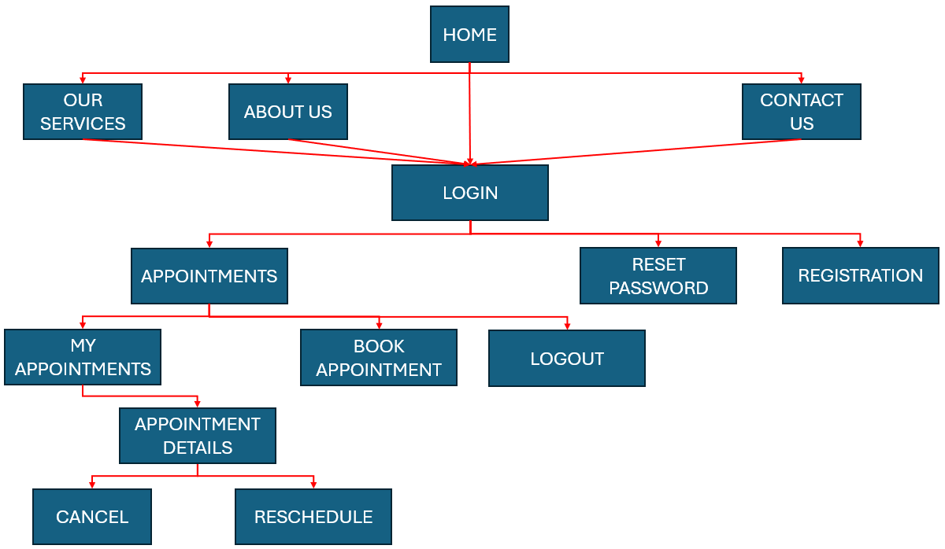

Doctor’s Site Map

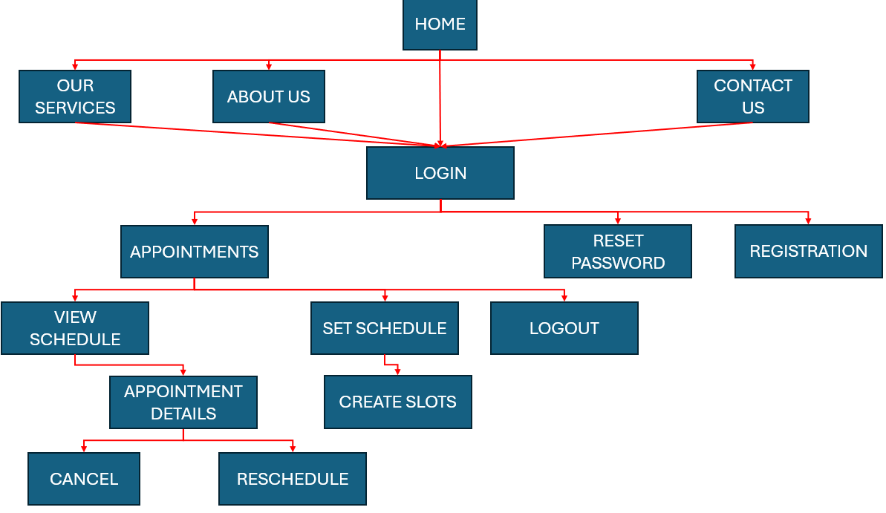

Admin’s Site Map

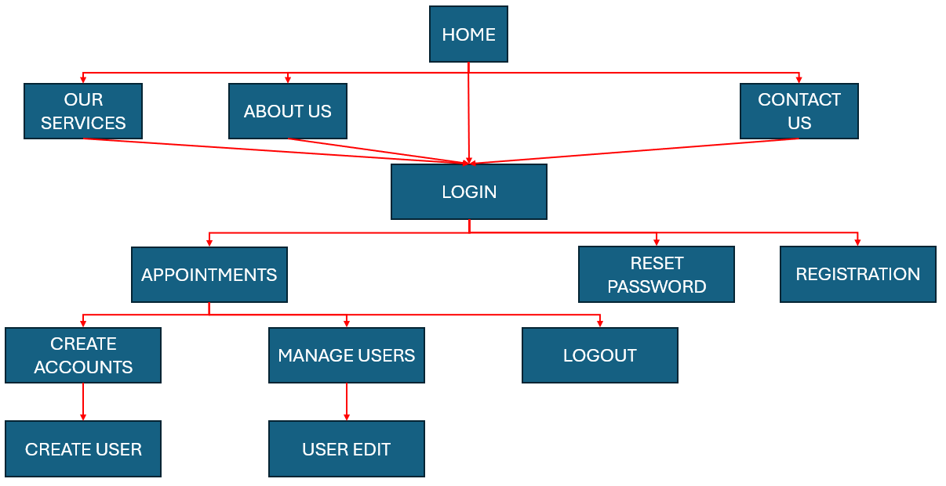

3.2 Storyboard

Booking an Appointment

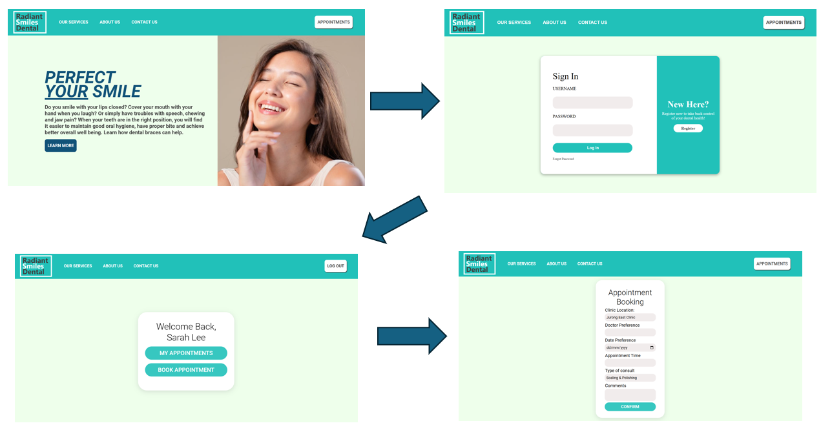Home page -> Login -> Appointments Page -> Appointment Booking Page -> Booking Confirmed

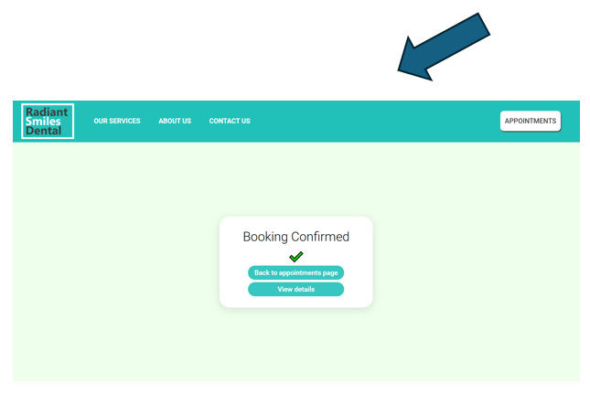

Navigation between public pages

Navigation between public pages can be done through clicking the links on the navigation bar.

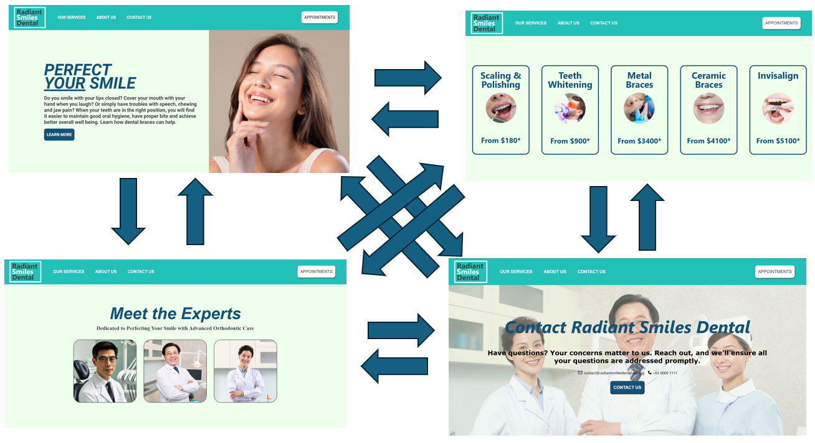

3.3 Wireframe

Home Page





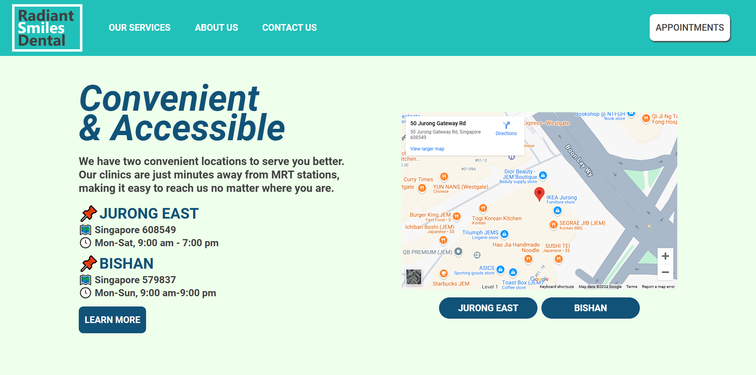

“Our Services” Page













“About Us” Page









“Contact Us” Page



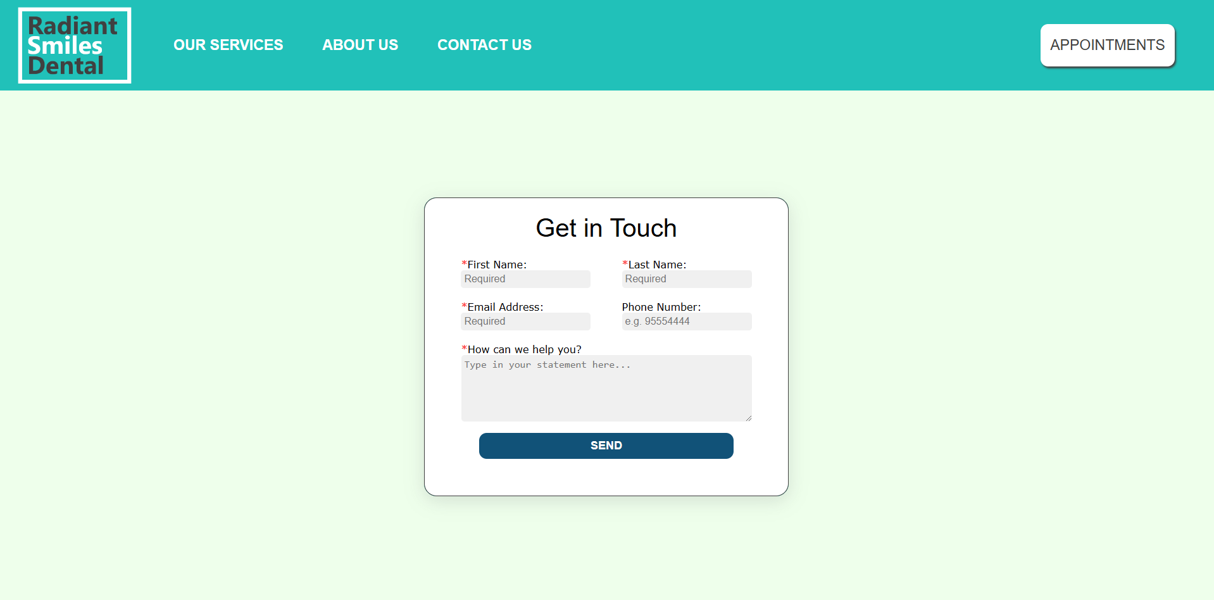



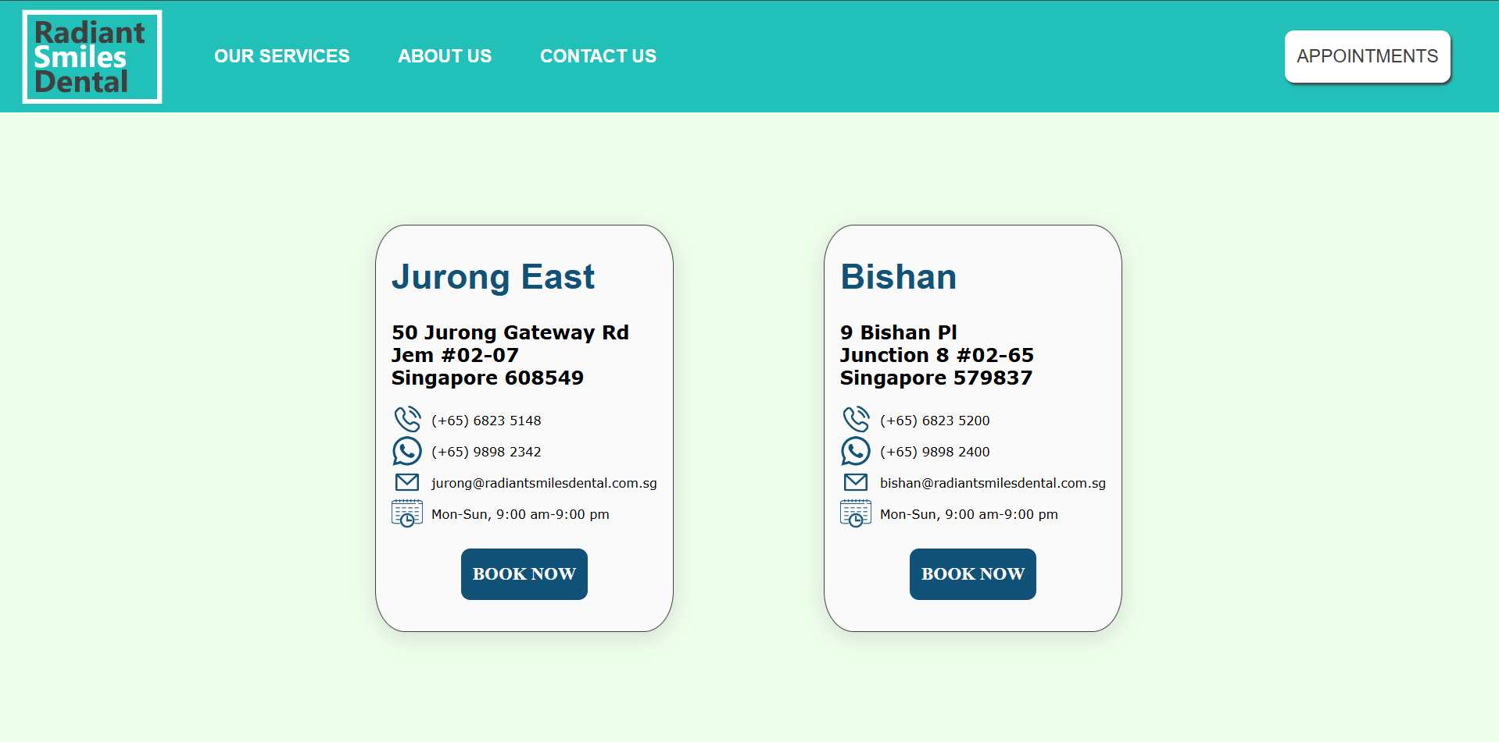

Login Page

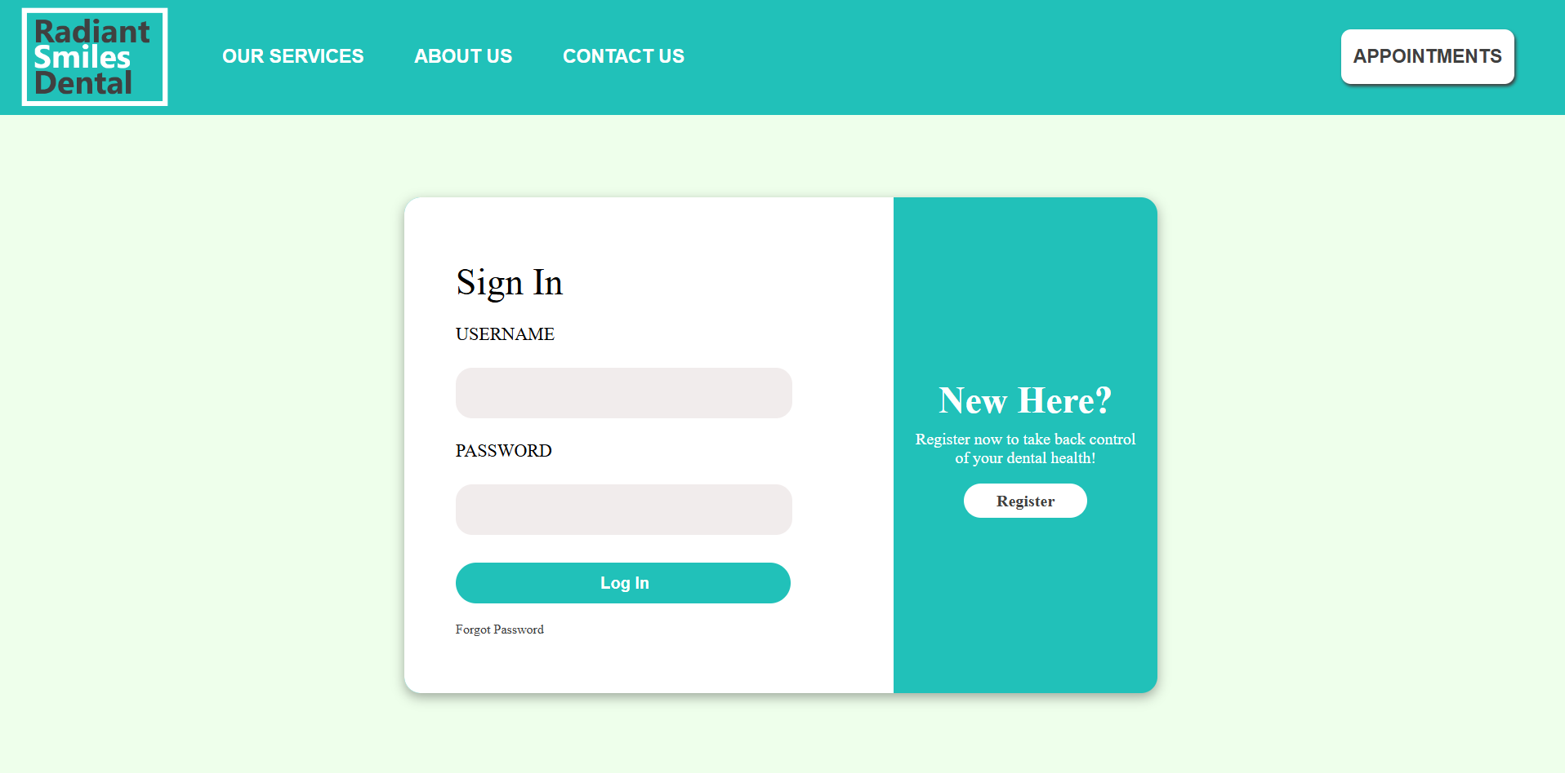

Registration Page

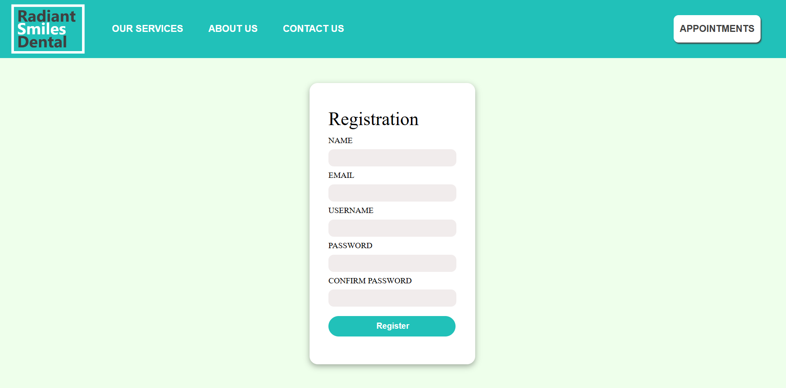

Reset Password Page

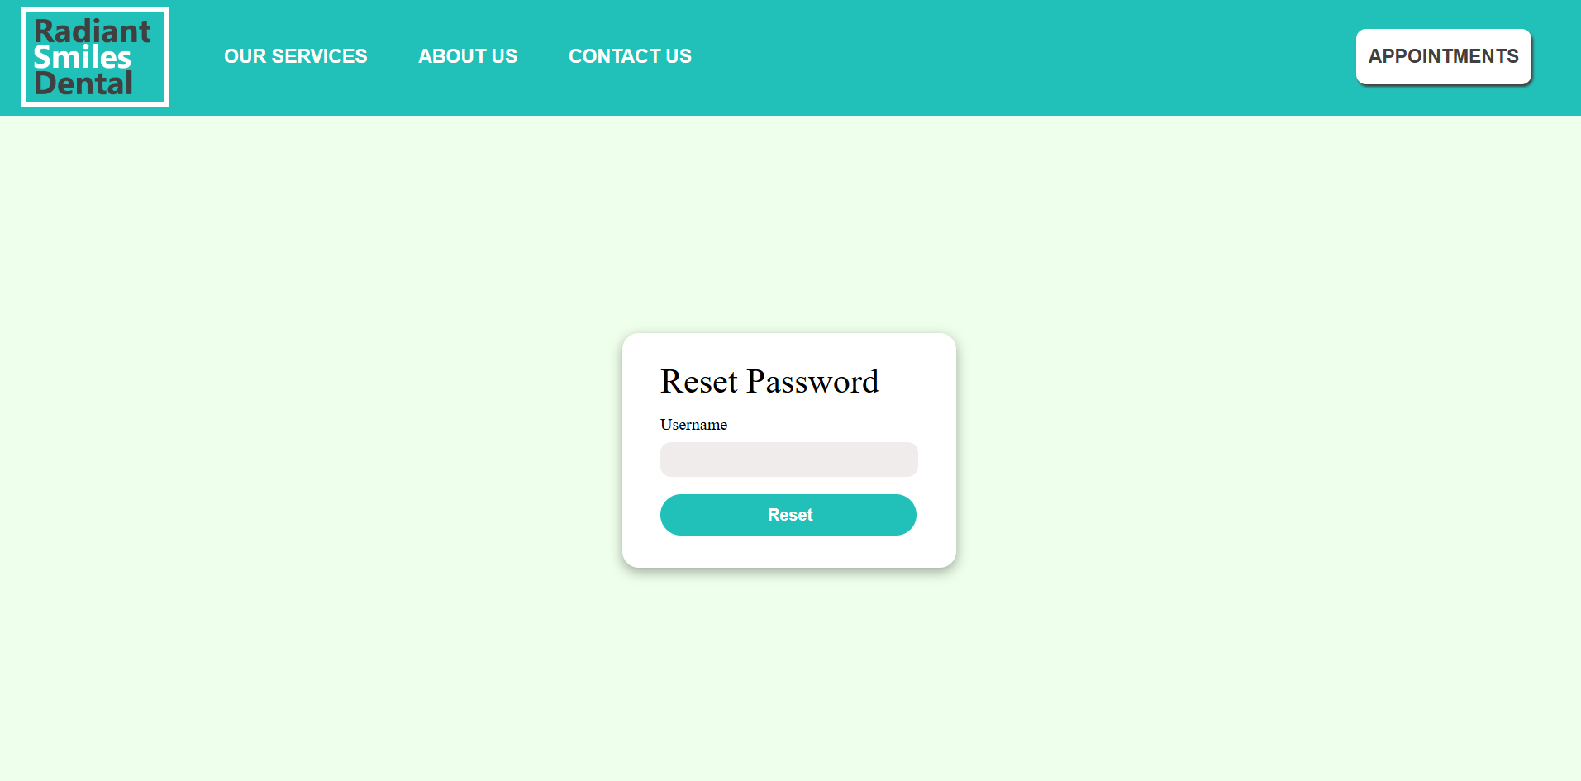

Patient Appointment Page

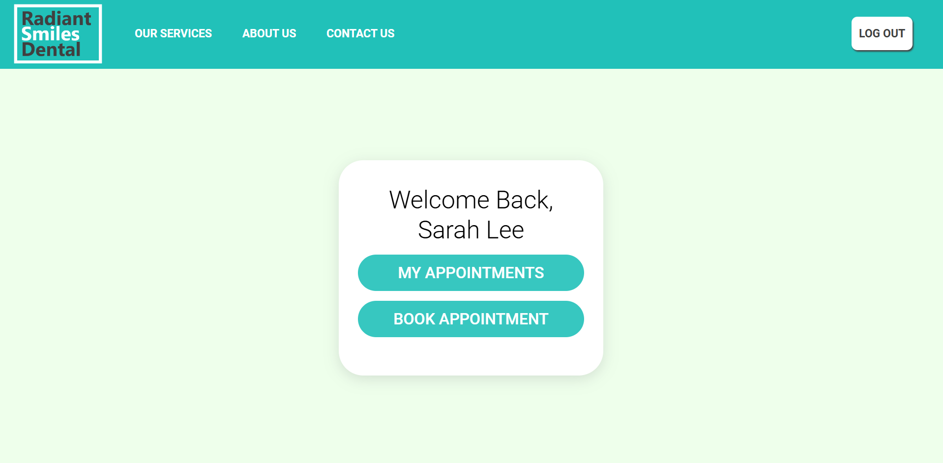

Appointment Booking Page

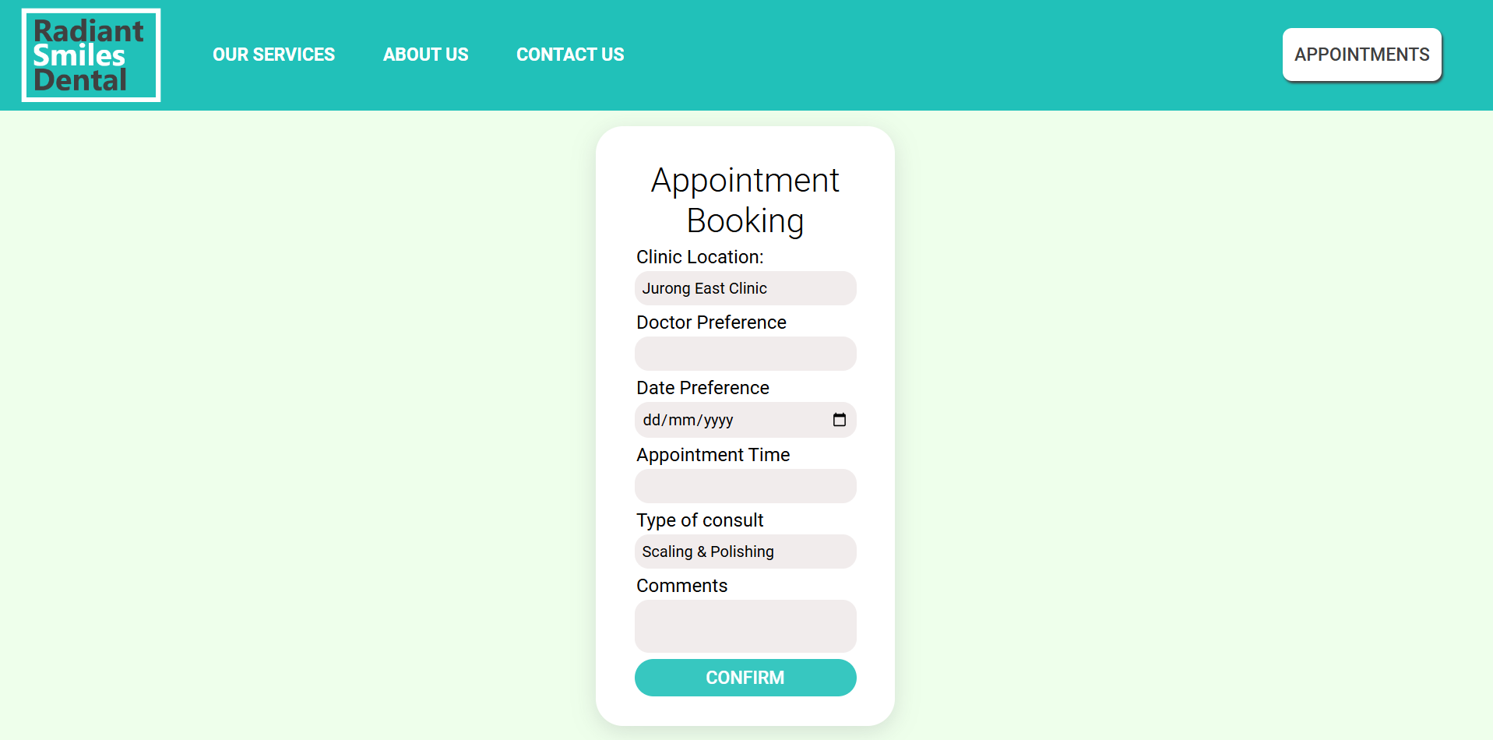

Booking Confirmed Page

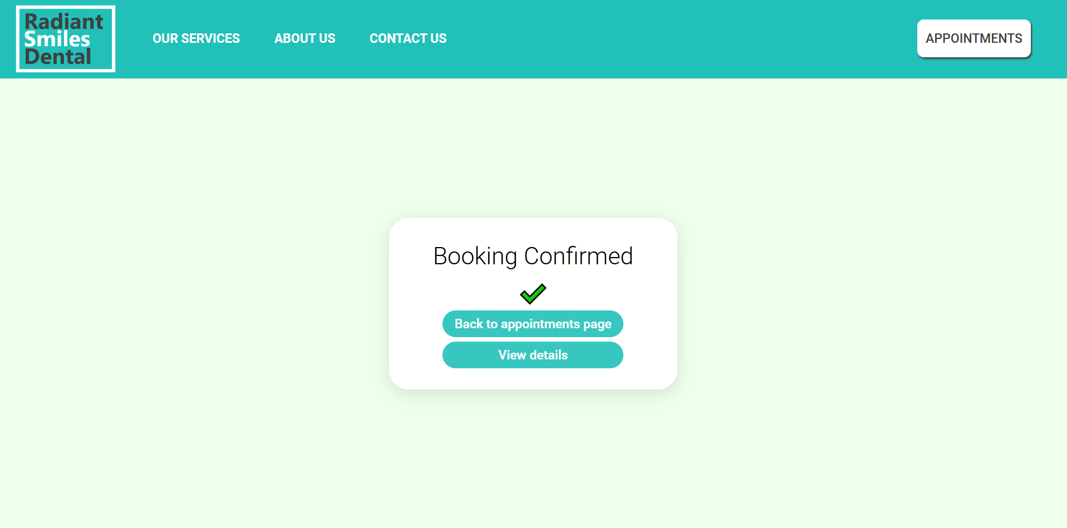

My Appointments Page

If no appointments:

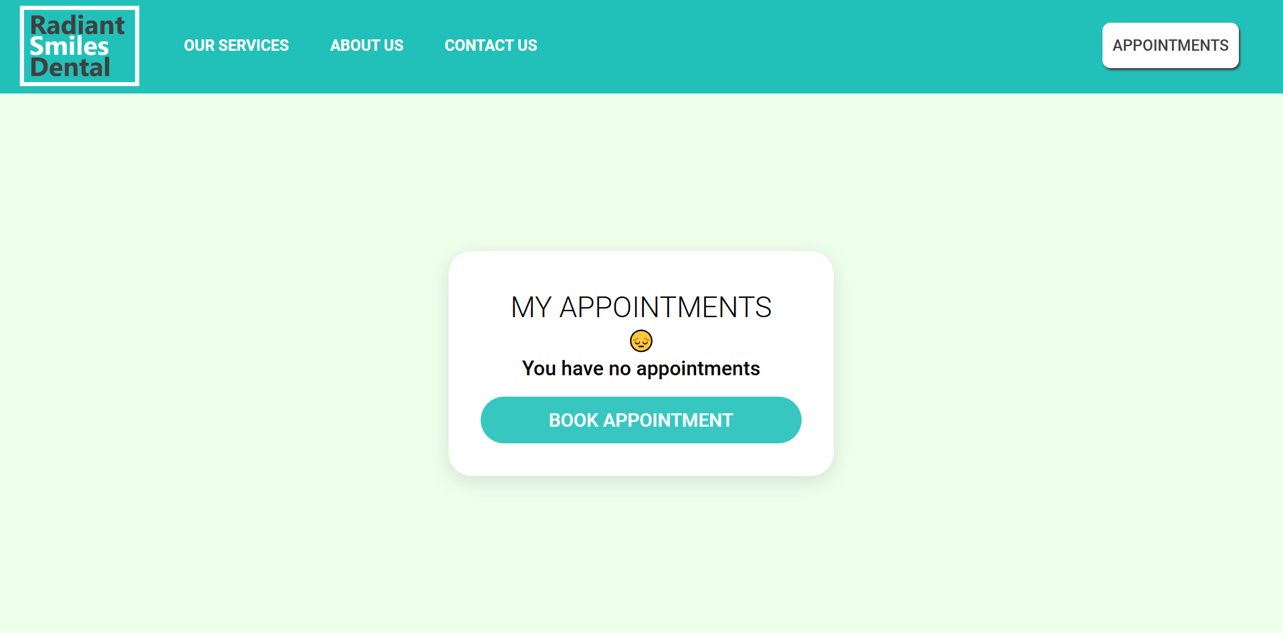

If there are upcoming appointments:

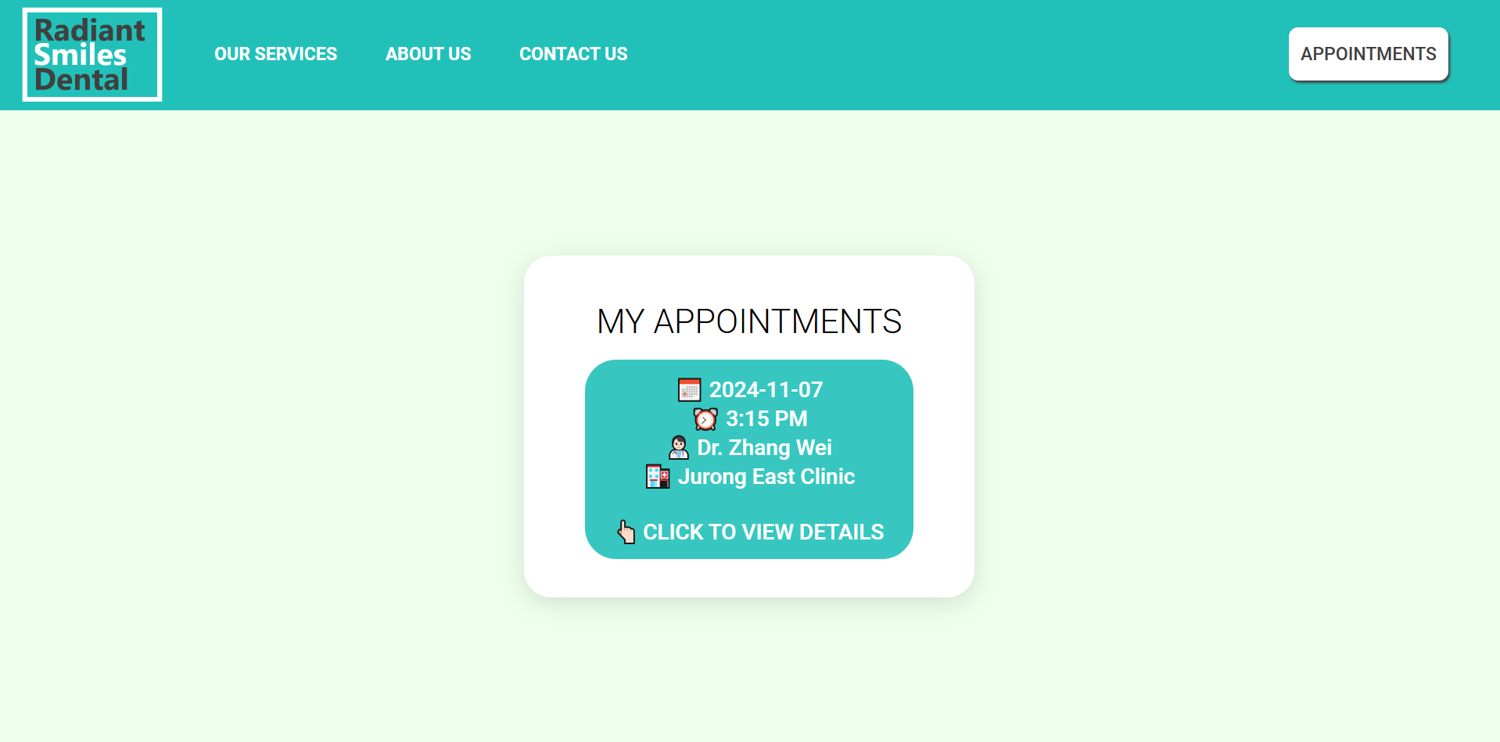

Patient Appointment Details Page

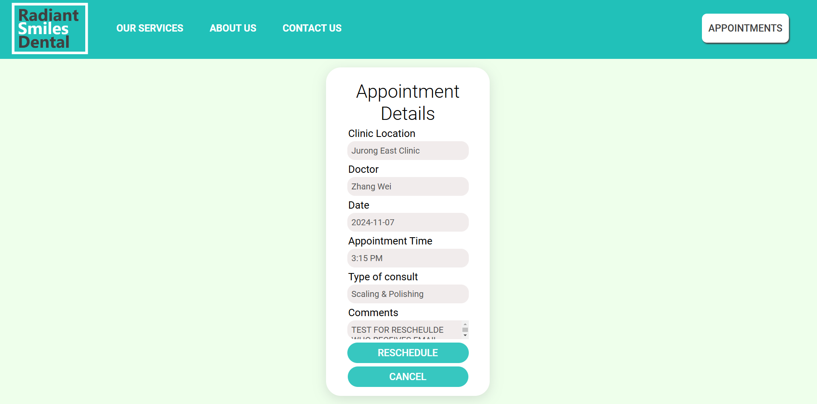

Reschedule Page

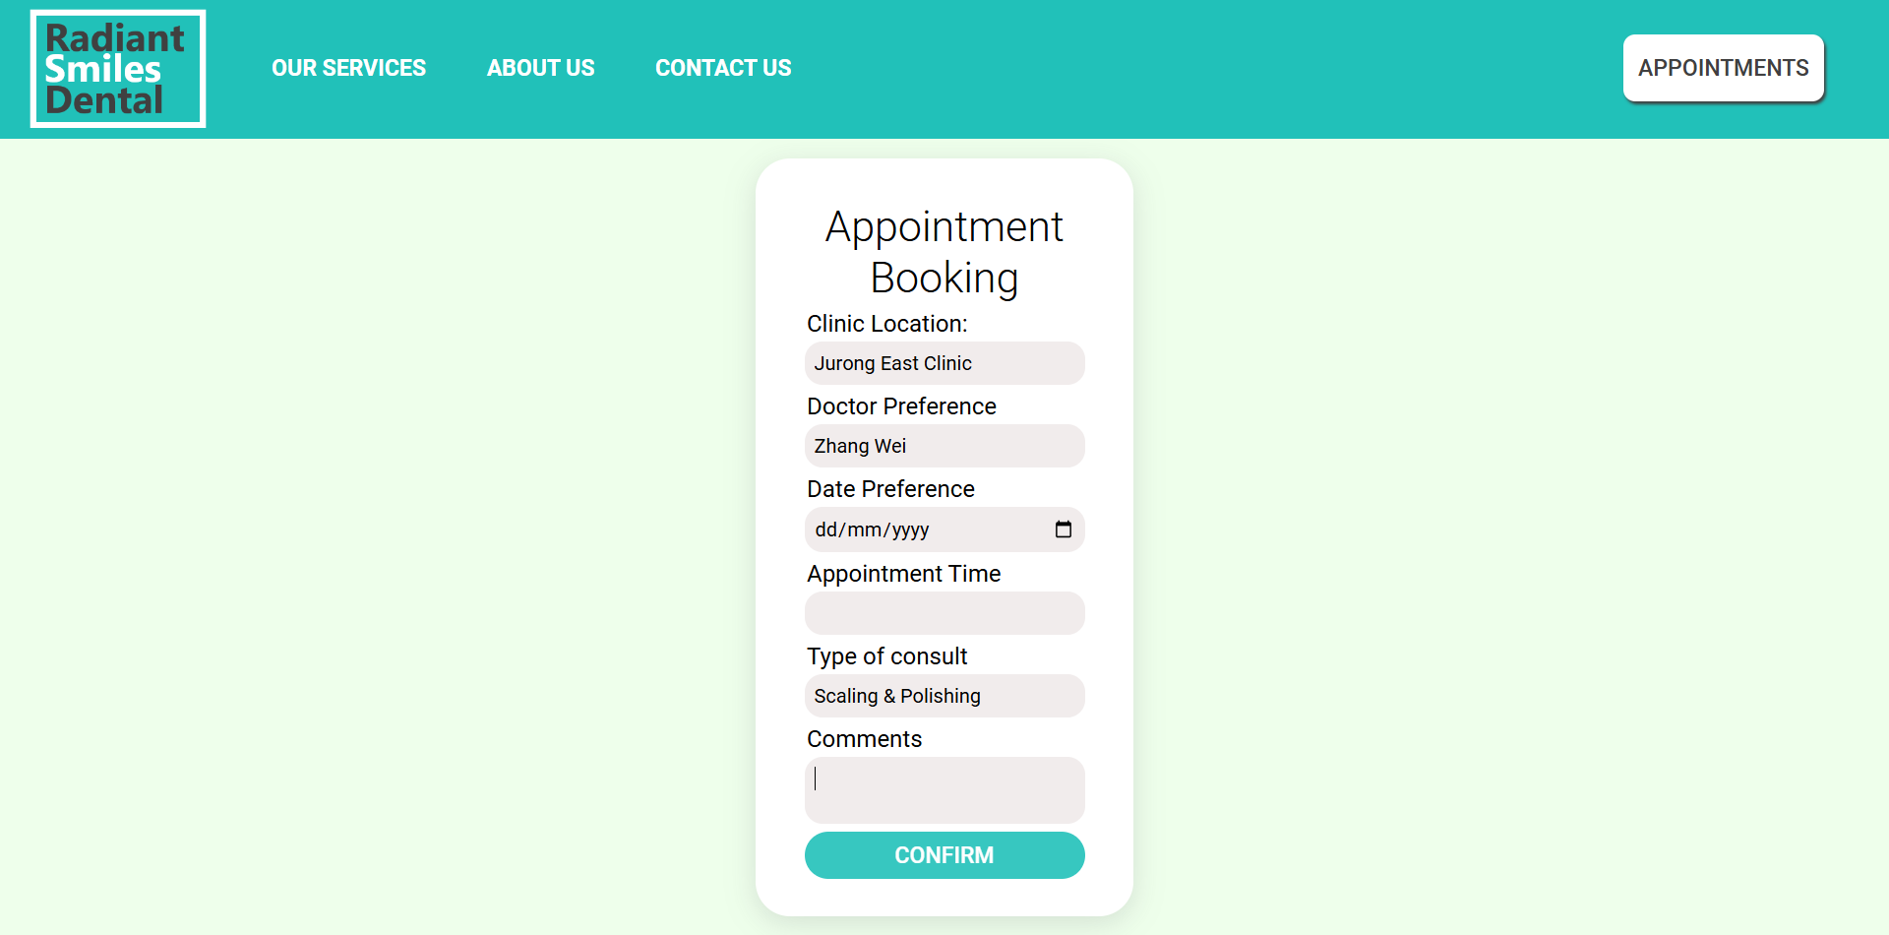

Doctor Schedules Page

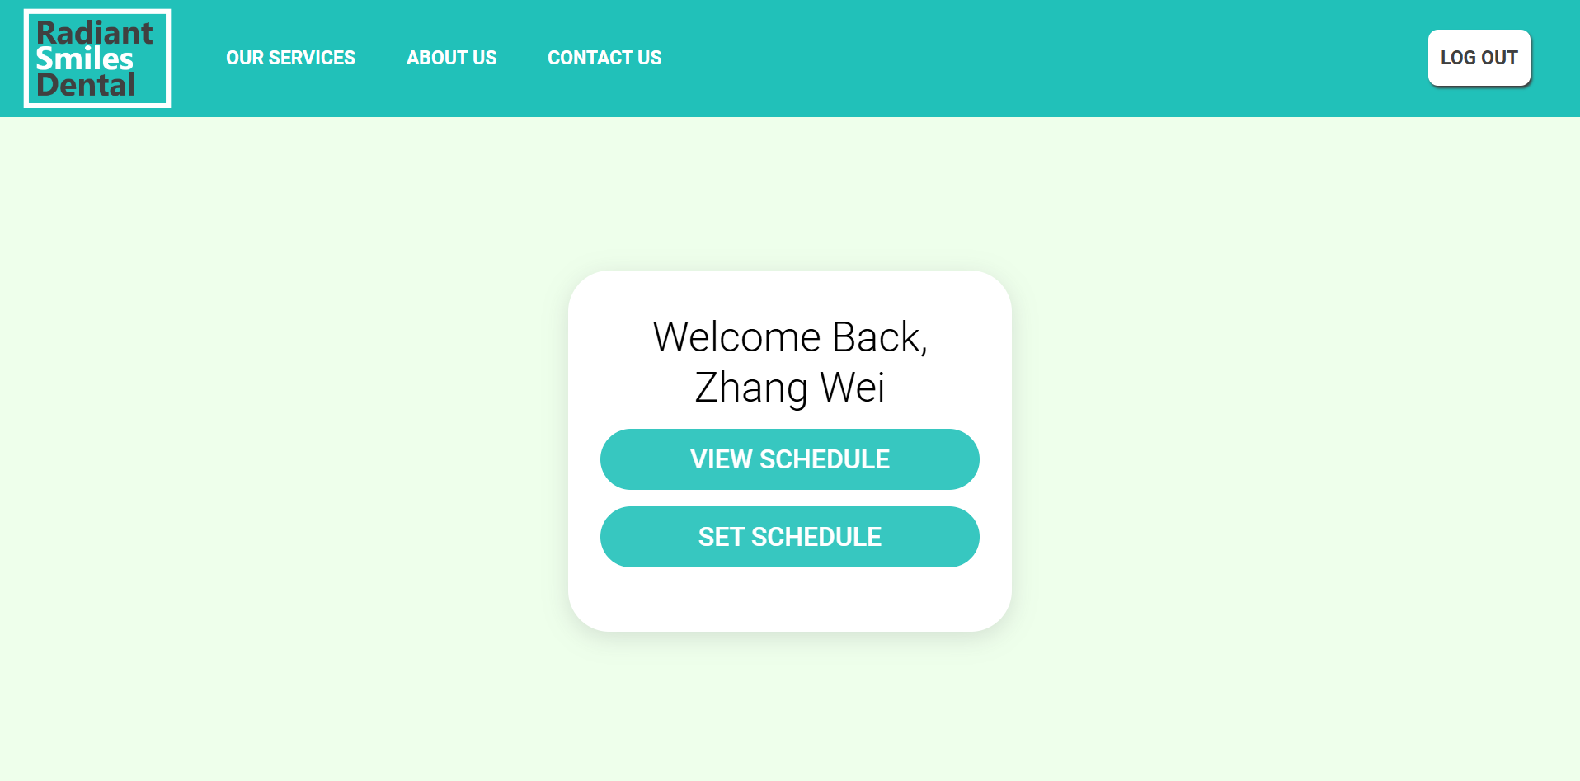

Doctor “My Schedules” Page

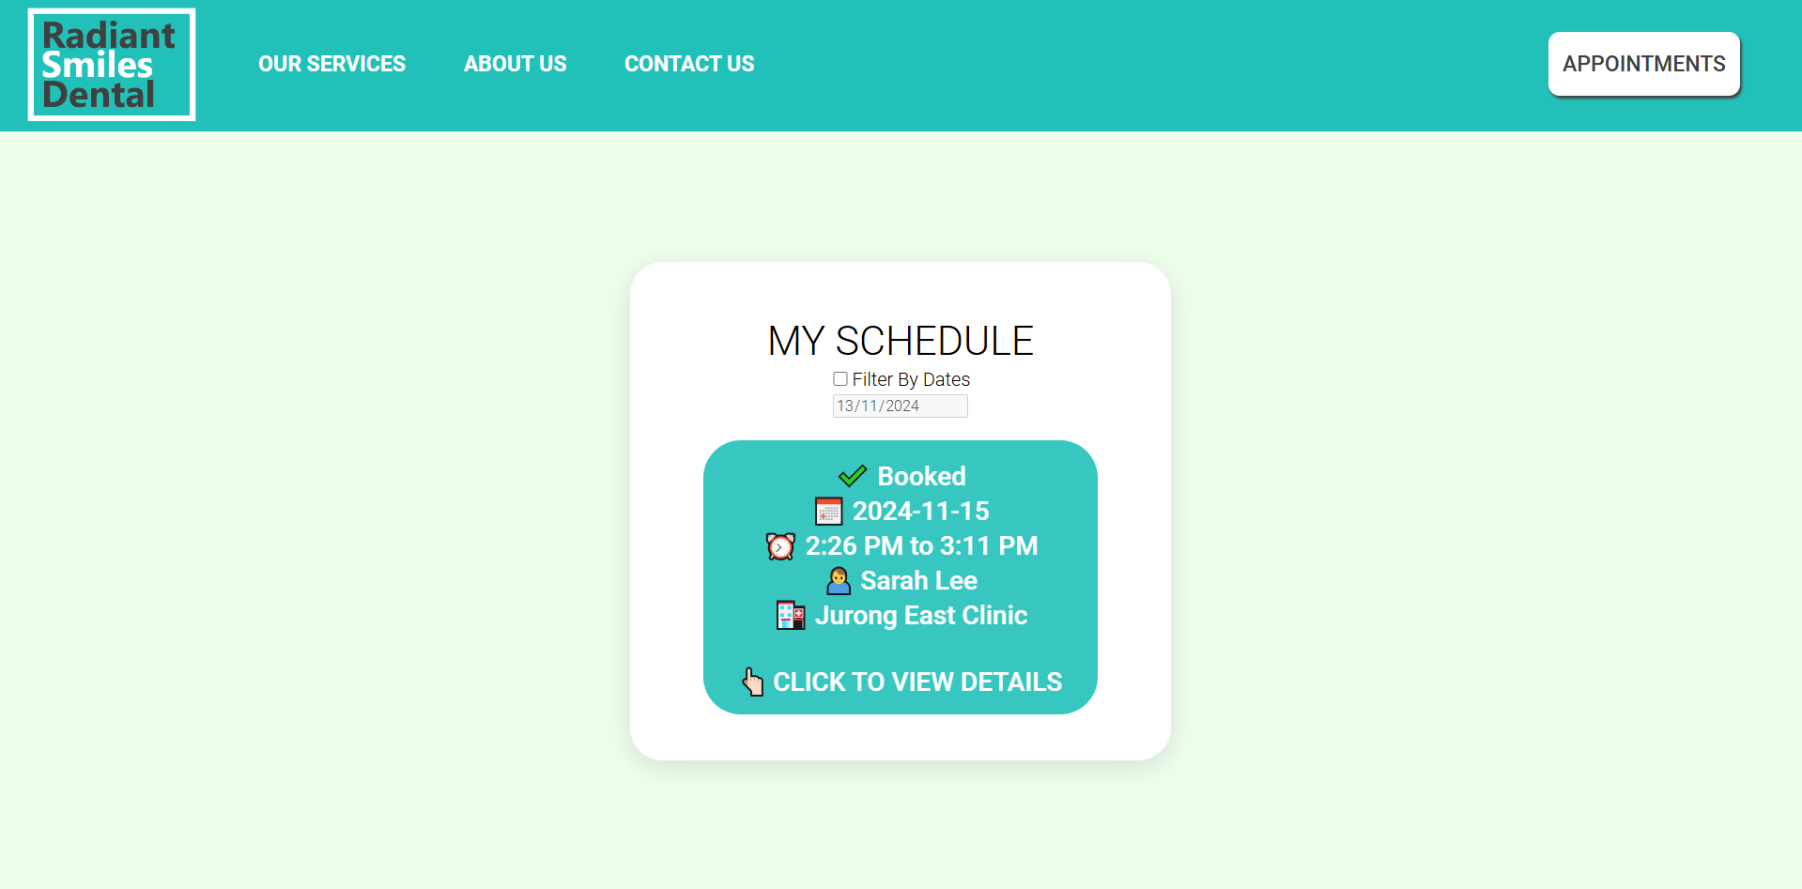

Doctor Appointment Details Page

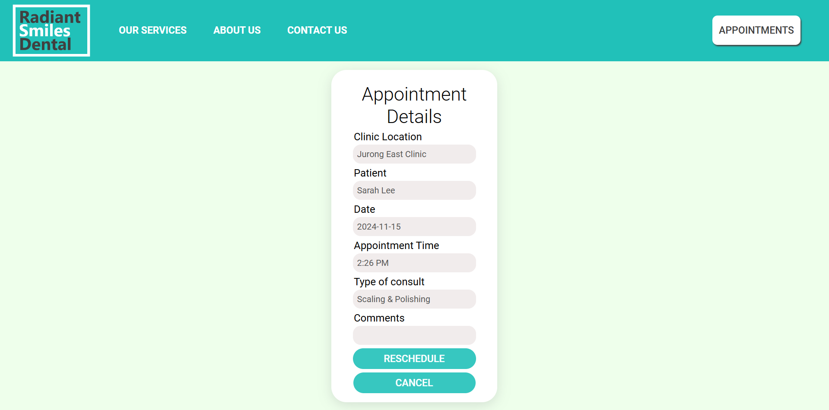

Doctor “Set Schedule" Page

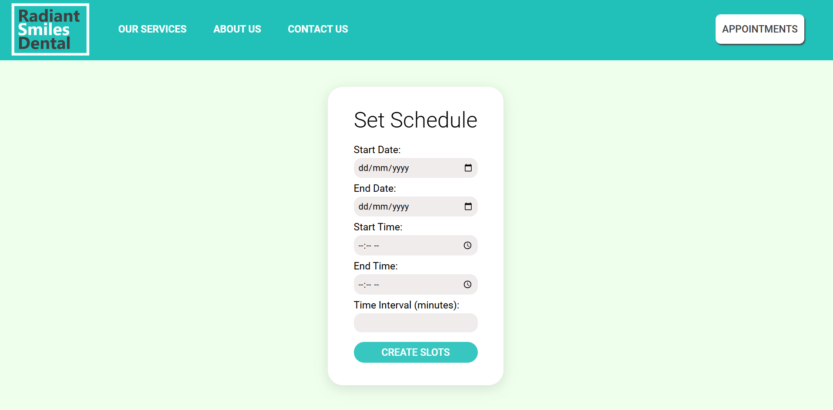

Admin Welcome Page

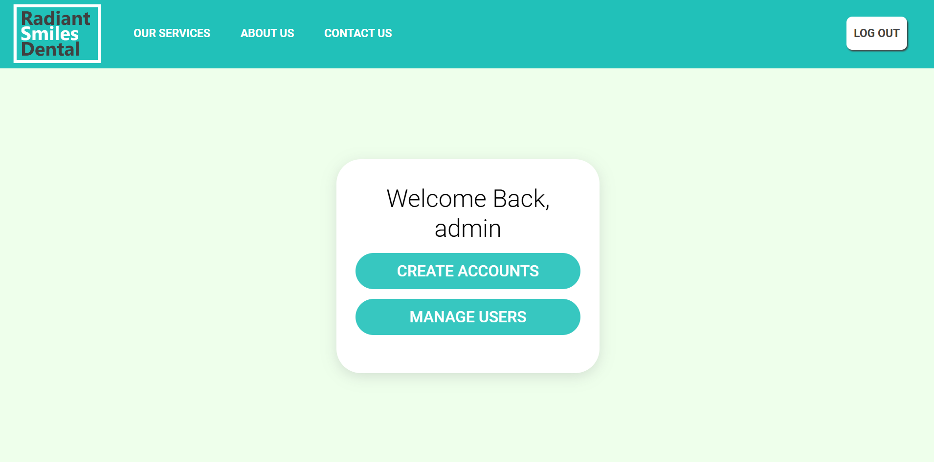

Admin Registration Page

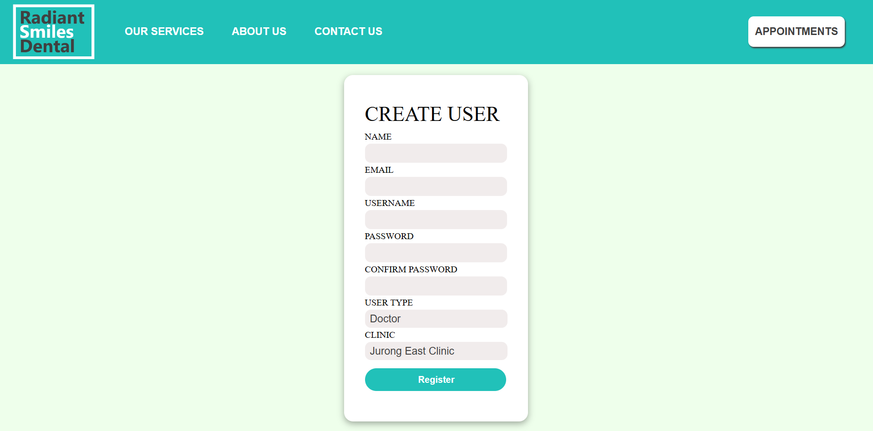

Admin User Management Page

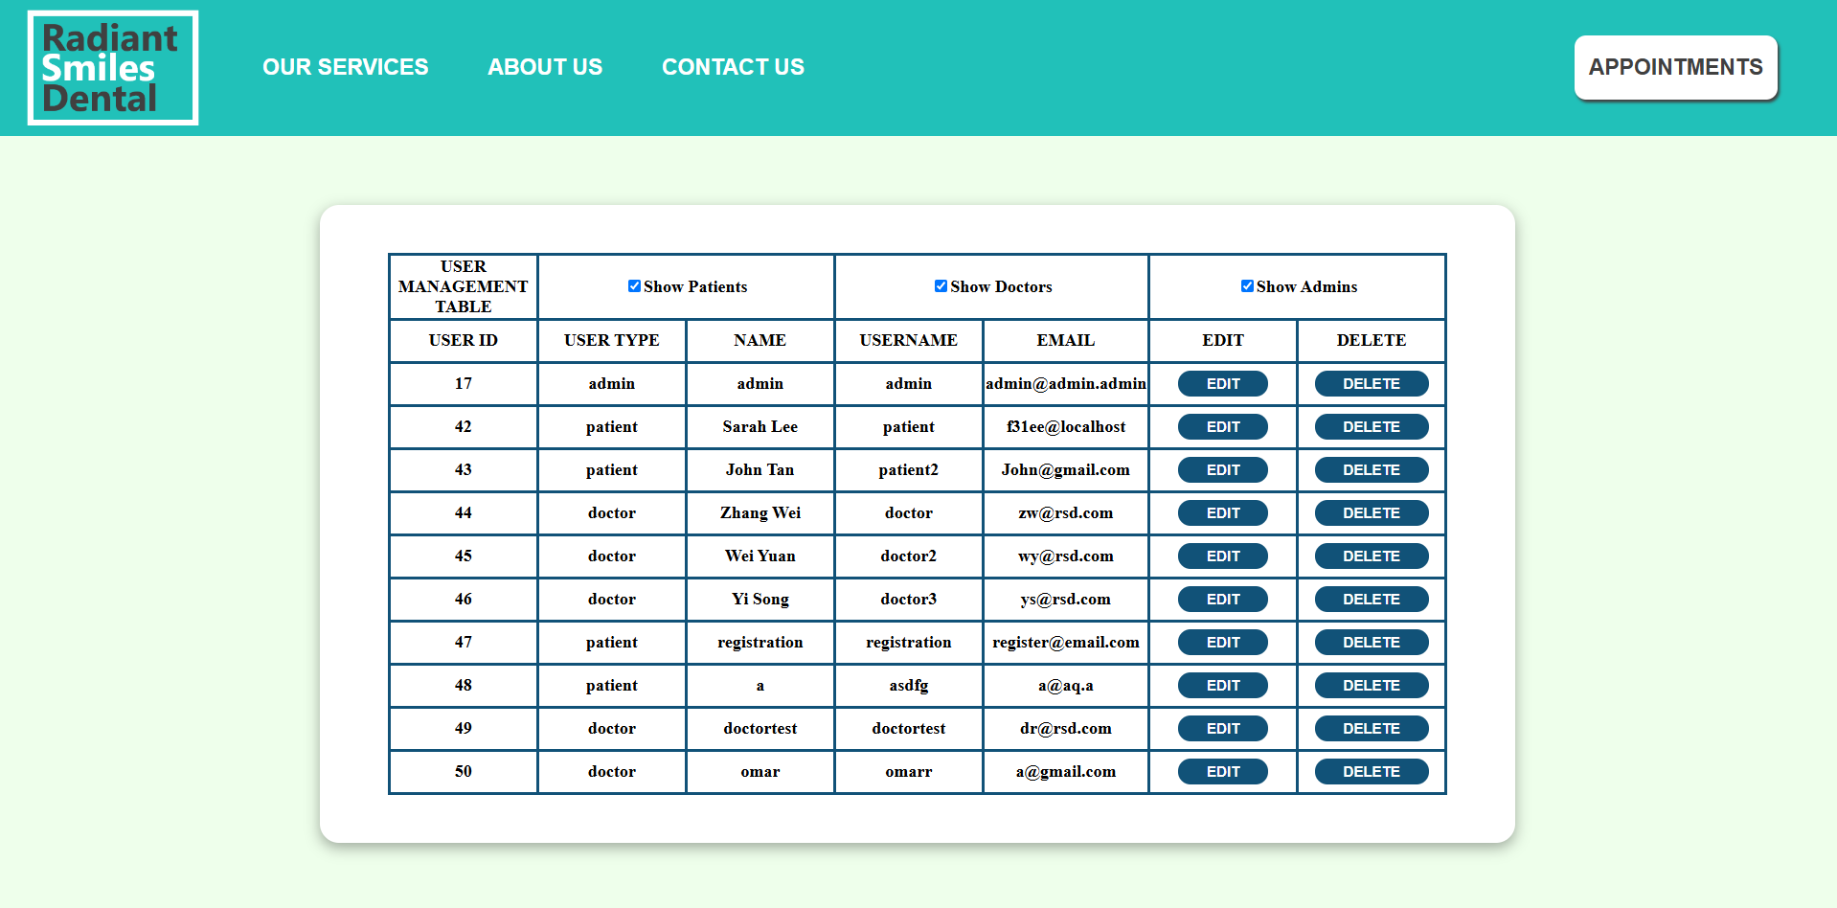

Admin User Edit Page

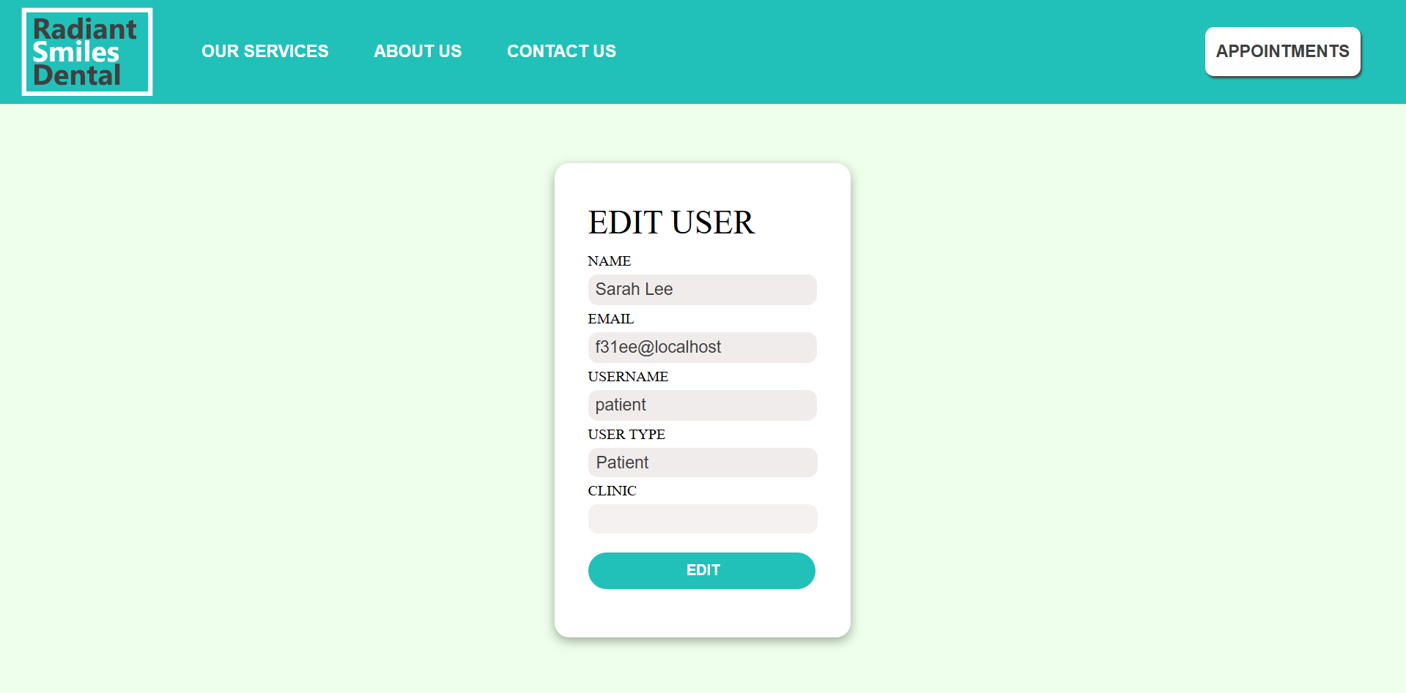

3.4 Database

Our database “dental” comprises of 3 tables: “appointmentslots”, “locations”, and “users”.

“appointmentslots” is a table that has the columns SlotID, DoctorID, AppointmentDate, StartTime, EndTime, IsBooked, PatientID, ConsultType, and Comments. New data entries are inserted into the table when a doctor sets his or her schedule. SlotID is the identification of the slot of type integer. DoctorID is the identification of the doctor of that slot. AppointmentDate is the date of the appointment of that slot. StartTime is the starting time of the appointment. EndTime is the ending time of the appointment. IsBooked shows whether that slot has been booked or not, with 0 indicating the slot has not been booked and 1 indicating that it has been booked. PatientID is the identification of the patient that has booked the slot. ConsultType is the type of consult for the appointment. Comments will be what the patient or doctor wrote in the comments text box when scheduling the appointment.

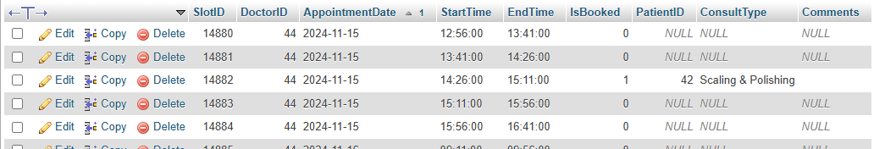

Figure : The “appointmentslots” table with an sample appointment scheduled.

“locations” is a table that has the columns user_id, doctor_name, and clinic to provide information on each doctor, their identification, and the clinic they are in. user_id is the identification of the doctor, of type integer. doctor_name is the name of the doctor. clinic is the identity of the clinic.

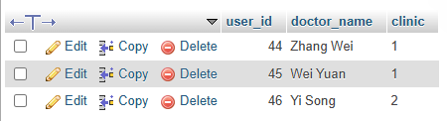

Figure : The “locations” table with the listed doctors.

“users” is a table that has the columns user_id, username, user_password, user_type, user_name, and email. It provides information on everyone registered in the system. user_id is the identity of the user, of type integer. username is the username of the user. user_password is the user’s password in hashed form for security purposes and to protect the password. user_type is the user’s type, that is, whether they are an admin, patient, or doctor. user_name, not to be confused with username, is the user’s name. email is the user’s email address.

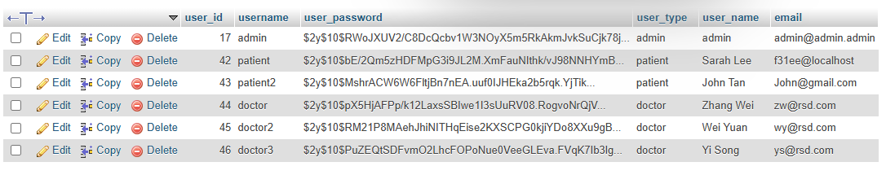

Figure : The “users” table.

3.5 Web Application Testing

**Test for negative inputs**: The web application should be able to handle invalid inputs. For example, we can test the e-mail field by inputting a string that does not follow the standard e-mail format.

**Test for invalid appointment bookings:** The web application should be up to date and only accept appointment bookings in dates that are in the future. The system should prevent the user from booking an appointment with a date that is in the past, which is an invalid booking.

**Test for overlapping bookings:** the web application should ensure that users cannot overwrite another user’s booking. We can test this by trying to book an appointment that overlaps with an existing appointment by another user. This is to prevent scheduling conflicts.

**Test for email:** ensure that the web application sends emails to the right recipients when an email function is carried out.

# Chapter 4 Implementation

## 4.1 Coding of the web page template

**4.1.1 Public Pages**

Navigation Bar



Figure : Image of navigation bar in appointments.php



Figure : Image of navigation bar in myappointments_client.php

The navigation bar is coded by creating a div which contains 3 other divs(left, middle and right). The left div contains a horizontally and vertically centered image tag with an a tag which redirects to the home page, whilst the middle contains a series of a tags which redirect to other public pages such as ‘our services’, ‘about us’ and ‘contact us’. Lastly, the right div contains an a tag which links to the logout.php file which logs out the user. In authenticated pages that are not the appointments.php , the right most div a tag instead points to the login page(login.php) which redirects to the appointments.php page due to a feature which in login.php if a user has been assigned a session variable named user_type of either patient, doctor or admin. The navigation bar also contains css styling such as hover pseudo element which allow there to be a simple animation when a user hovers over the various a tags.

Home Page (index.html)

The home page is split into 3 parts that were compartmentalised into divs. The first div (id = “bottom-header”) comprises of 2 divs, left-body and right-body. left-body contains two p tag texts (id = “Text1” and “Text2) and an anchor tag leading to the ‘Our Services’ page. In the css, all the elements in left-body were given animations using keyframes. Text1 and the anchor tag were given the animation fadeIn where the element fades into frame. Text2 was given the animation slideIn where the text would slide in upwards, starting from a position that is 10% below the text’s given position on the y-axis. Text2 and the anchor tag were given delays in their animations so that there is a flow in the sequence of animations, where the main text Text1 shows first, followed by Text2, then the anchor tag. The “bottom-header” div also has another div (id = “right-body”) which initially contained an image that would show on the right. This image was later replaced by another image that became bottom-header’s background image, but we decided to keep the right-body div so that we did not need to make any changes to the css code for left-body.

The second div of the home page (id = “bottom2”) comprises of 2 divs (id = “b2-upper” and “b2-lower”). b2-upper contains a p tag text (id = “text3”) that is the main text. b2-lower contains 3 divs (id = “b2-lower-1”, “b2-lower-2”. “b2-lower-3”) that contain information about the doctors. They each contain an img tag of width 180px of their respective doctor, followed by 2 p tags. The first p tag contains the doctor’s name and the second p tag contains their credentials.

The third div of the home page (id = “bottom3”) comprises of 2 divs (id = “b3left” and “b3right”). b3left contains a div (id = “bottom3-header”), which contains 2 p tags that contain the main texts, followed by a div (id = “bottom3-content”) and an anchor tag that leads to the ‘Contact Us’ page. bottom3-content contains the content information about the clinics, all written inside 3 p tags. b3right contains 2 iframes which show maps of the 2 clinics, and another div which contains 2 buttons that say “JURONG EAST” and “BISHAN”. The buttons have JavaScript commands that run when they are clicked which makes the map shown alternate between the 2 clinics. In the JavaScript script, there are 2 functions “bclick()” and “jclick()”. For bclick(), the map for “JURONG EAST” will be hidden, and the map for “BISHAN” will be visible, and vice-verse for jclick().

‘Our Services’ Page (services.html)

**4.1.2 Authenticated Pages**

In our project, pages that require a user to be logged are referred to as authenticated pages, examples include appointments.php, myappointments_client.php and appointments_client_view.php.

For authenticated pages, pages have a few common features. Firstly, a navigation Bar which is reused from the public pages. Secondly, below the navigation bar is a div within a div, the nested div contains the content we display to the user. The nested div contains a table in which the data is presented to the user which may also contain a form if user data needs to be submitted to the server. Each page also has session handling which contains code that checks if a user has the valid session variable ‘user_type’ for the respective page.

Session handling



Figure : Session handling in appointments.php

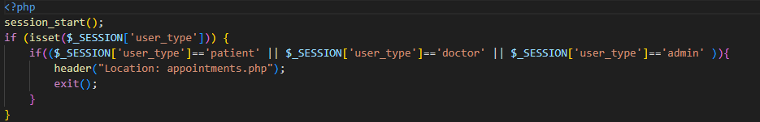

Figure : Session handling in login.php

For all authenticated pages, we first check if session variable ‘user_type’ is set, if user_type is not set or user_type is not valid we redirect user to login.php. If user_type is set but is not the correct type, login.php will then redirect the user to appointments.php . This system prevents unauthorized access to our authenticated pages. Valid ‘user_type’ values depend on the type of page, for example appointments.php (default user logged in home page) is accessible to all ‘user_type’ (patient, doctor and admin) however certain pages such as user_management.php is only accessible to ‘user_type’ admin.

## 4.2 Coding of the pages

**4.2.1 Public Pages**

**4.2.2 Authenticated Pages**

For the Authenticated pages, we will be breaking down the coding of the pages into 3 parts, pages for patients, doctors and admin.

**4.2.2.1 Patients**

**4.2.2.1.1 appointments.php**

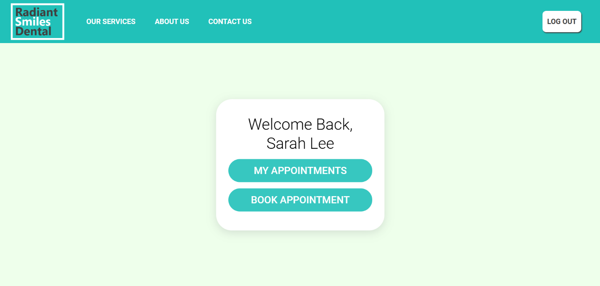

Figure : Image of appointments.php (Patient View)

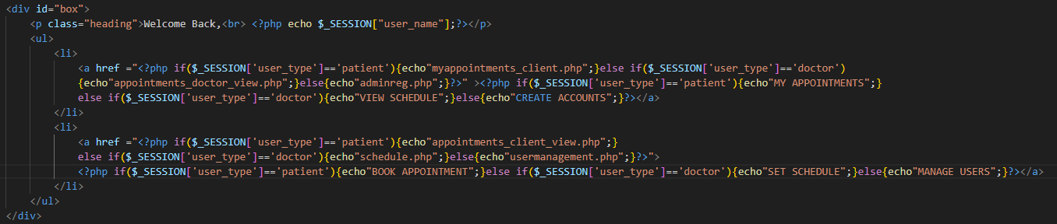

Figure : Portion of appointments.php code

Other than the page template code previously discussed, the div box in the center contains a table with the user’s name, and two a tags which link to myappointments_client.php and appointments_client_view.php . The user’s name is determined by accessing the session variable ‘user_name’. The ‘my appointments’ and ‘book appointments' a tags as well as the link is determined by using an if else statement that checks session variable ‘user_type’.

**4.2.2.1.2 myappointments_client.php**

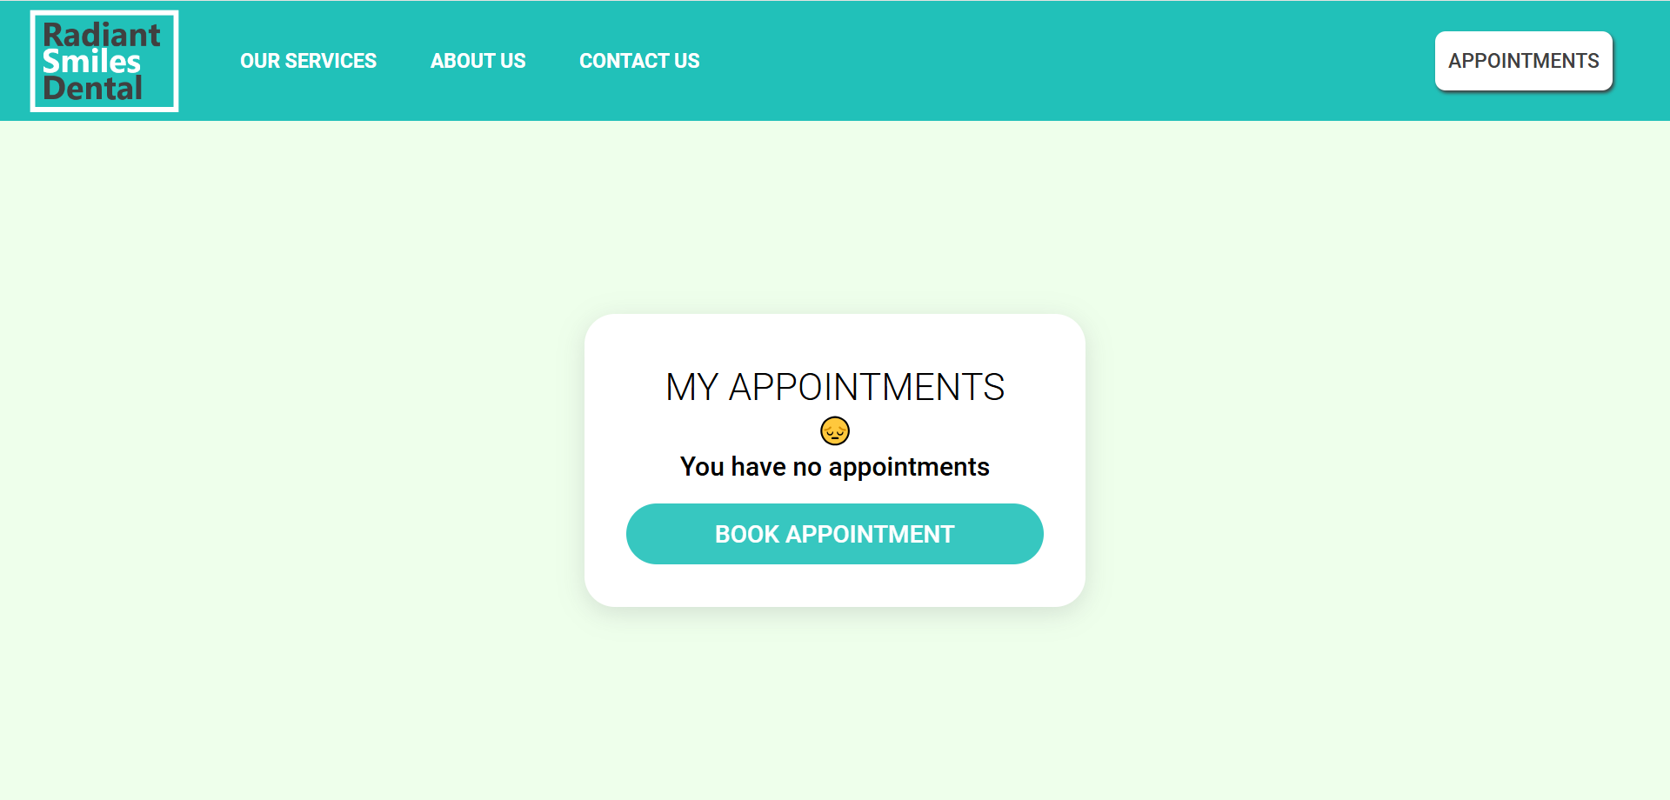

Figure : Image of myappointments_client.php (If user has no appointments)

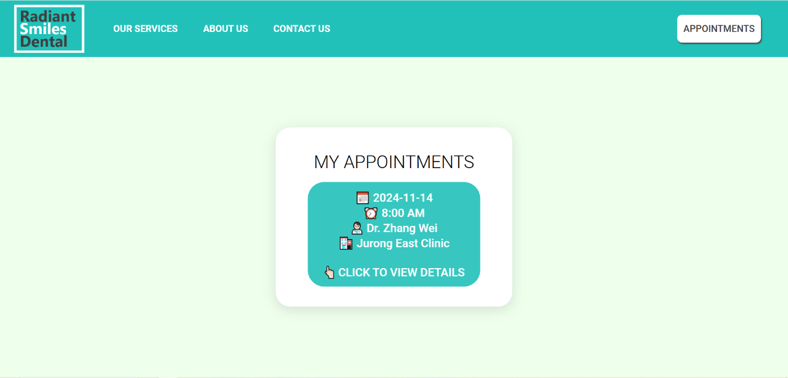

Figure : Image of myappointments_client.php (If user has 1 or more appointments)

The page first queries the appointmentslots table from the database with the user’s $_SESSION[‘user_id’] for all the appointments the user has. If the user has no appointments the page displays that the user has no appointments and links and option to book an appointment. If the user has 1 or more appointments, we create a form with a button with the details of the appointment for each of these appointments. For each of these buttons we also query the doctor’s name from locations table using the ‘DoctorID’ obtained in the first query. Using CSS, we also style each button to have an animation on hover. Lastly, each button is also a form which links to the appointment details (apptdetails.php) associated with each appointment when clicked, we achieve this by setting each button’s value with the associated appointment id (‘appt_id’).

**4.2.2.1.3 appointments_client_view.php**

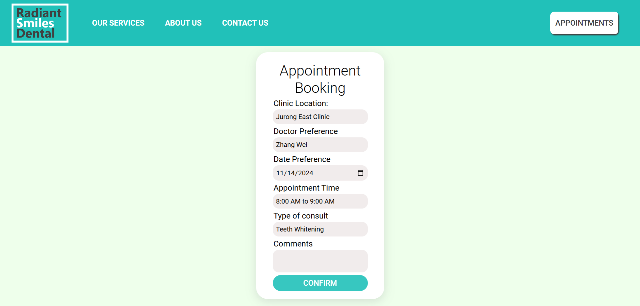

Figure : Image of appointments_client_view.php

This page allows the user to book an appointment. When the page loads, the page first queries all available doctors from the locations table in the database as well as all available appointment slots that are not booked (IsBooked=0 means appointment is not booked) from the appointmentslots table. The div box in the center contains a table which contains a form. The table contains a select option for clinic locations. When the user selects a clinic location, the associated doctors available at the clinic location, we achieve this in the earlier query where we set the doctors as options in the select tag for doctor preference, we differentiate each location’s doctor by setting their class as clinic location. When a specific clinic location is chosen, we use javascript to hide the options with doctors not at the selected location by setting the hidden tag to true and unhide the options with doctors at the selected location by setting the hidden tag to true. Next we provide a date input field for the user to pick their desired date, we use javascript to ensure the user is only able to pick tomorrow’s date and onwards. Once the doctor preference field and date preference is chosen, the available timeslots for that specific doctor on that specific date is displayed in the select tag for appointment time, this process is largely similar to the method we used for displaying of doctor preference select tag, we differentiate each appointment slot by setting each option tag with three classes, the Doctor_ID appointmentdate and bruh(common class name used for hiding of element). When the Doctor preference and appointment date is set or changed, we use javascript to hide all option tags that do not match both the doctor_id and appointment date and unhide all the option tag that match both doctor_id and appointment date using the hidden attribute. We also use javascript to alert the user if the doctor has no available time slots on a specific date they have chosen by using the alert function. Then, the user is prompted to enter the type of consult they wish to book. Lastly, we also have a text input for the user to input their desired comments. We also use the html required attribute to ensure all fields except comments are required before submission. When all field are entered and the form is submitted, it links to confirm_booking.php . By design, the user can only choose a valid timeslot as all appointmentslots are queried directly from the database, there is also an edge case where an available appointment slot is chosen by the user but is booked by another user after this page has been loaded, this edge case is covered by code within confirm_booking.php that only confirms the booking at the point where the form is submitted.

**4.2.2.1.4 confirm_booking.php**

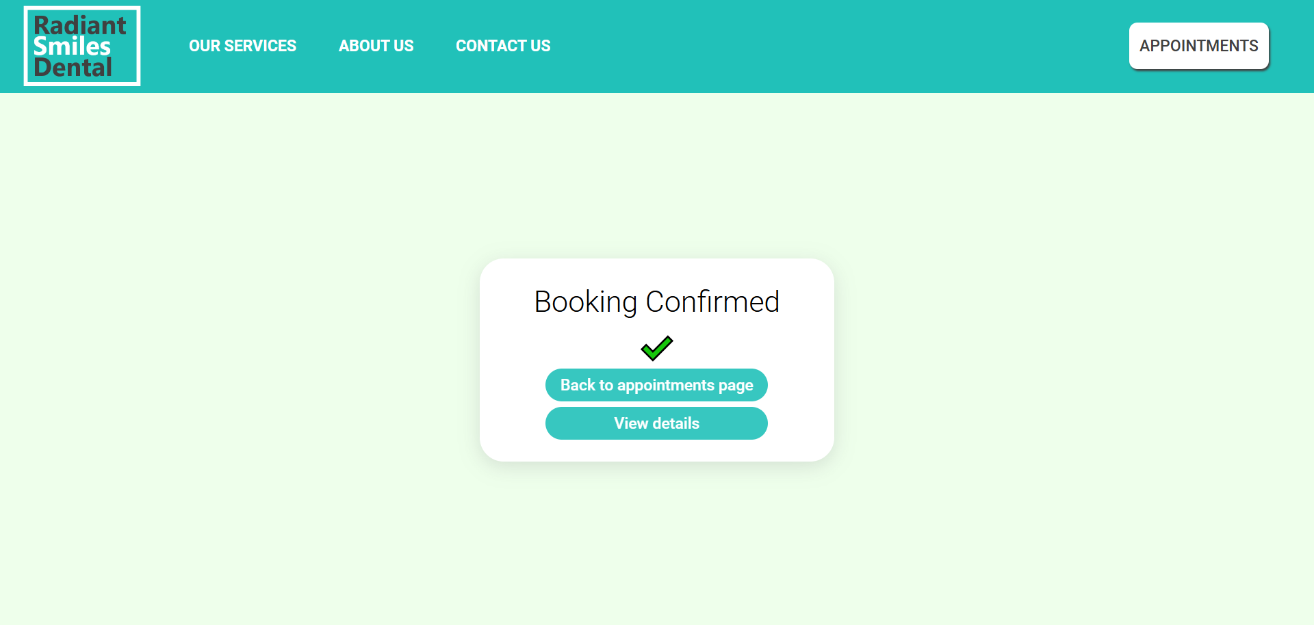

Figure: Image of confirm_booking.php (Successful booking)

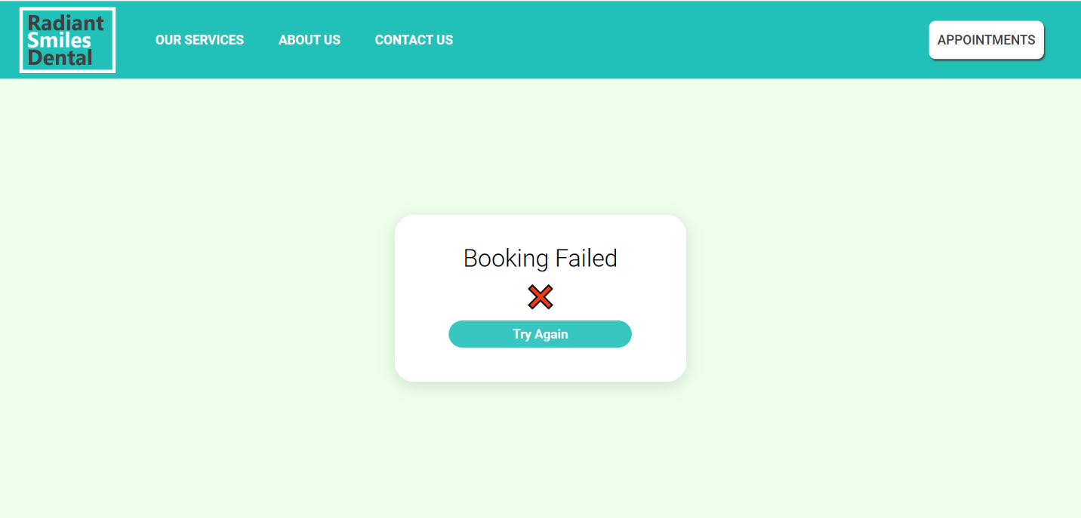

Figure: Image of confirm_booking.php (Failed booking)

The page first uses the $_POST variables passed from booking page (appointments_client_view.php) or rescheduling page(reschedule.php), namely SlotID to query the appointmentslots table to check if the appointment slot has been booked. If the appointment slot is unavailable the page will display ‘Booking Failed’. If the appointment slot is available the page checks if the $_POST variables received has been sent from reschedule.php or booking page, this is achieve by checking if $_POST[‘link’] is set, if it is set the previous page is the rescheduling page otherwise it is from the booking page. If the data is passed from the rescheduling page, we must first unbook the first appointment slot that the user wishes to reschedule. Then we book the new appointment. If the data is passed from the booking page, we can simply book the new appointment.

If the booking has been successful, the user will be given two forms each in a table row with a tags to go back to apppointments.php or view the specific details of the appointment (apptdetails.php). The ‘view details’ submit button form contains a hidden input ‘link’ which contains the SlotID of the booked appointment

If the booking has failed the user will be given a single form which links the user to the booking page(appointments_client_view.php) when clicked.

**4.2.2.1.5 apptdetails.php**

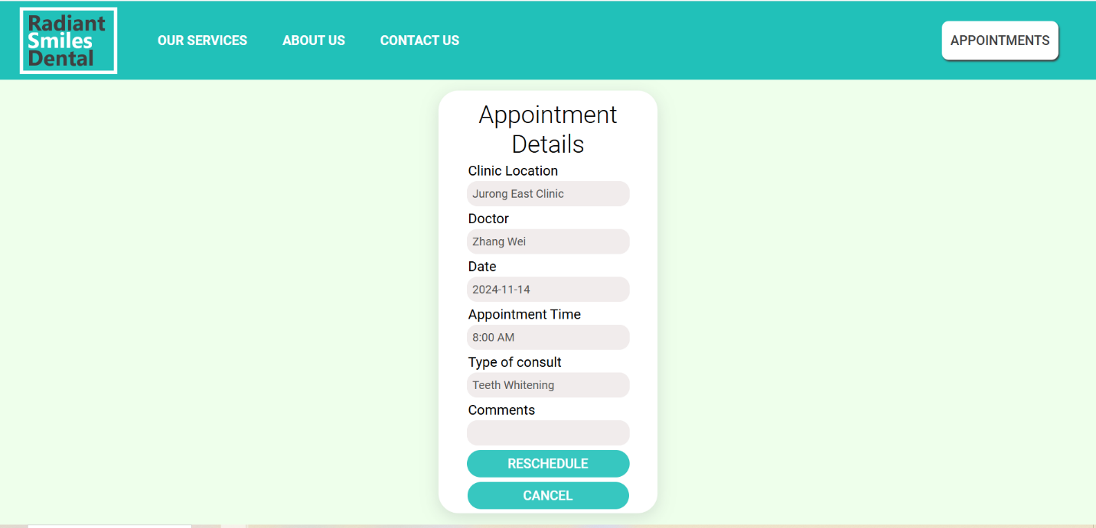

Figure : Image of apptdetails.php

The page, first receives $_POST[‘link’] from either confirm booking page (confirmbooking.php) or my appointments page (myappointments_client.php). $_POST[‘link’] represents the appointment SlotID, which is used by the page to query the appointmentslots and location table for the appointment’s data which is then displayed in a table format, note that the fields in this page cannot be edited and are view only using the disabled attribute. There are two forms one for rescheduling and one for cancelling, each form has an element which contains the value equal to the appointment_id with the name ‘link’. When the user clicks on either ‘reschedule’ or ‘cancel’ the form action is triggered which directs to reschedule.php and cancel.php respectively. Cancel.php

**4.2.2.1.6 reschedule.php**

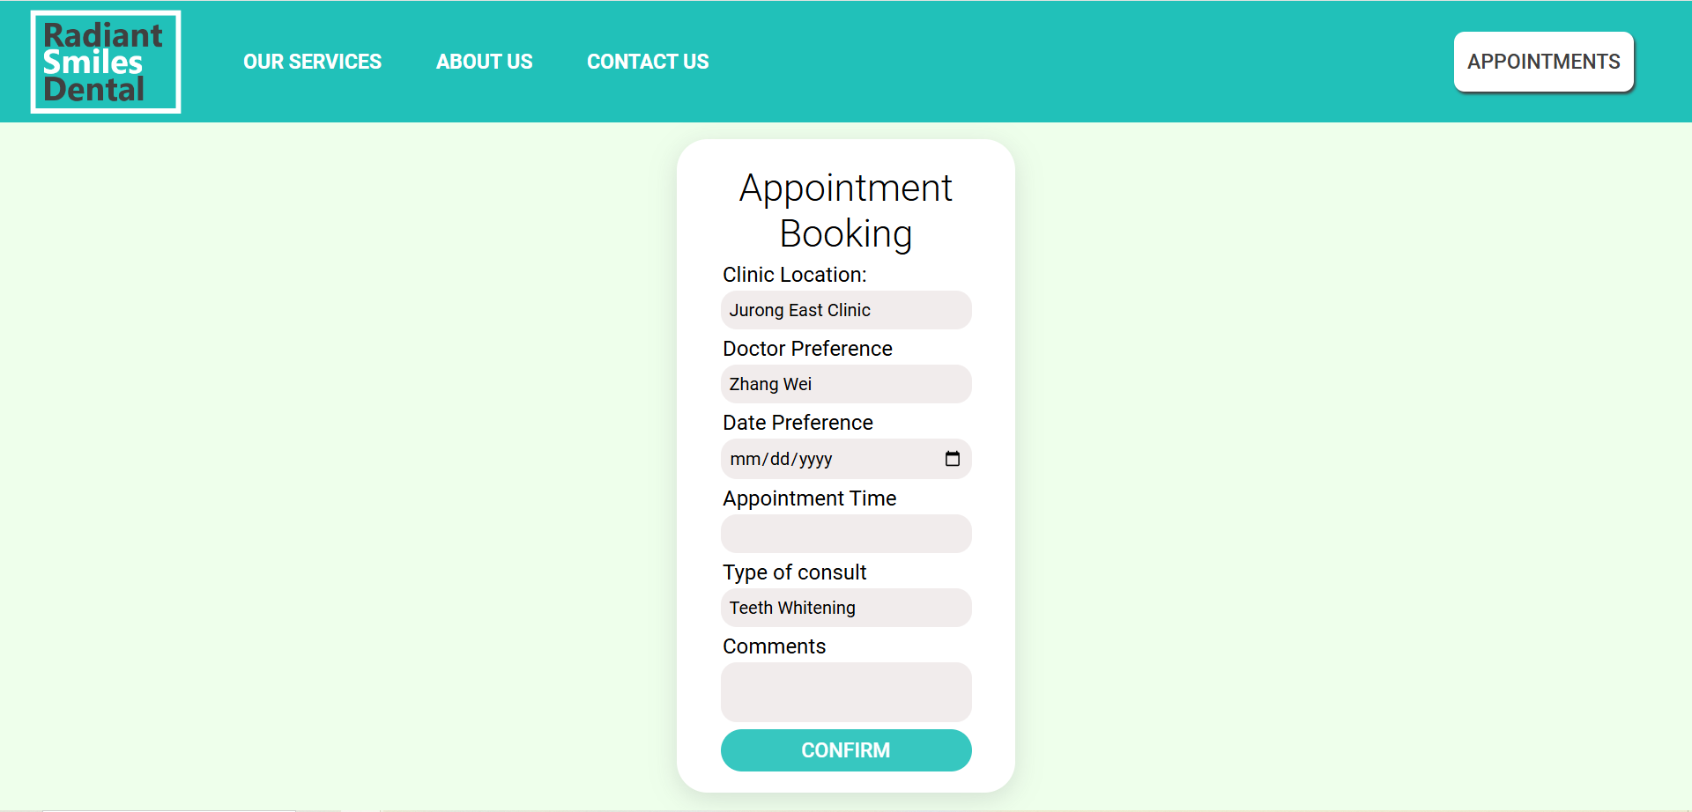

Figure : Image of reschedule.php

The coding of reschedule.php is almost exactly similar to the bookings page (appointments_client_view.php) except that the $_POST[‘link’] which represent appointment SlotID has been received so we can pre-populate the clinic location, doctor preference and type of consult from the original appointment. The user is still able to change these options if they want to. Allowing the user to change all aspects of the appointment but provides some convenience by pre-filling some of the table’s data by assuming the user wants to retain the same clinic location, doctor preference and type of consult.

**4.2.2.1.6 cancel.php**

cancel.php is a backend page which is not directly viewable to the user that is only available from the appointment details page (apptdetails.php), its function is to cancel an appointment. By receiving the SlotID via $_POST[‘link’] we can delete the associated appointment slot from the appointmentslot table.

This page is available to both patients and doctors via apptdetails.php and apptdetailsdr.php respectively.

**4.2.2.1.7 logout.php**

logout.php is a backend page which is not directly viewable to the user that is only available via the main page (appointments.php), it’s function is to logout the user.To logout the user, we simply destroy the session using session_destroy(); and redirect to the login page.

This page is available to all users, patients, doctors and admin via the appointments.php page.

**4.2.2.2 Doctor**

**4.2.2.2.1 appointments.php**

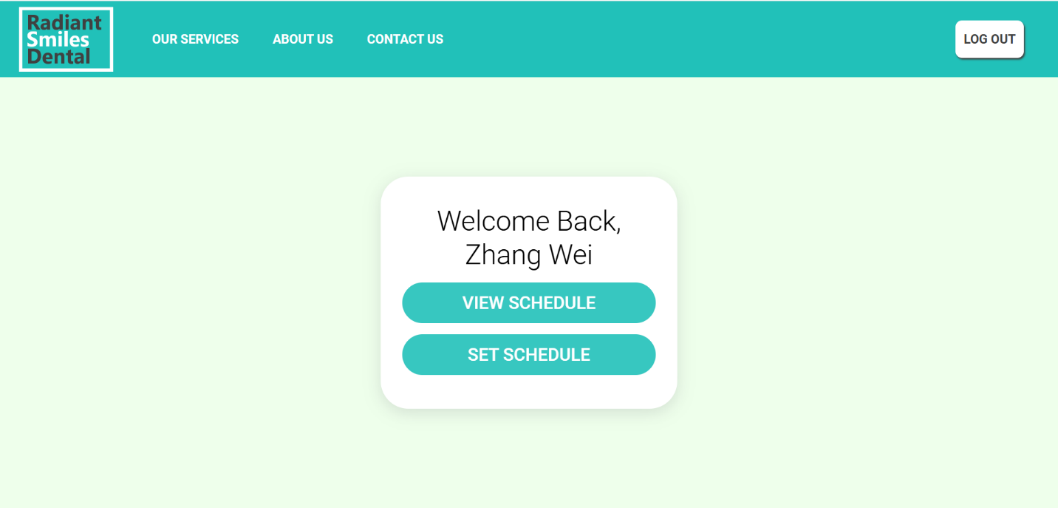

Figure : Image of appointments.php (Doctor View)

This page is similar to the client view version as seen earlier. Except that the two a tags in the table are linked to the view schedule page (appointments_doctor_view.php) and set schedule page (schedule.php)

**4.2.2.2.2 schedule.php**

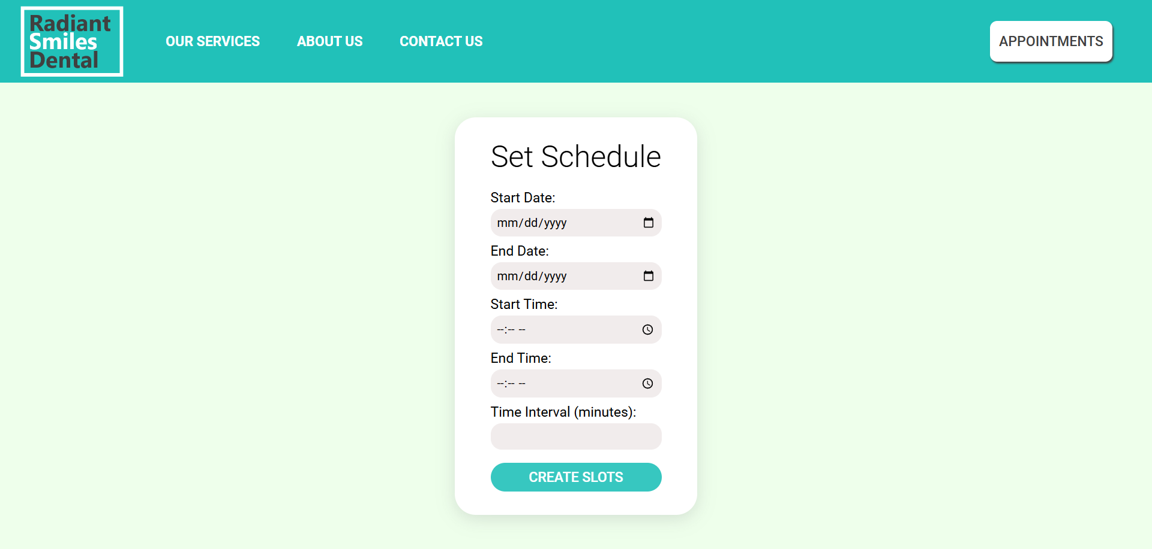

Figure : Image of schedule.php

The page consists of a div in the center which contains a form in a table, there are 5 input fields, first and second are date input fields, third and fourth are time input fields. Fifth is a number input field. The page uses javascript for form validation, we first check that the end date is not before the start date. Second, we ensure that end time is not before start time. Lastly, we ensure that the time interval is more than 0. We use the html required attribute to ensure all fields are filled before submission, on submission we link to generate_slots.php . Compared to other designs, our scheduling system design allows doctor to pick a custom schedule to work, this means allowing them to pick their own days as well as setting their own amount of allotted time for each appointment slot, this allows for a high degree of user autonomy.

**4.2.2.2.3 generate_slots.php**

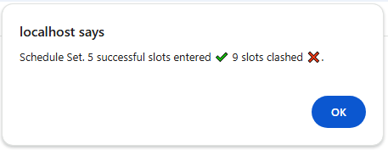

Figure : Image of alert after generate_slots.php redirect to appointments.php (Case of partial successful and failed inputs)

generate_slots.php is a backend page which is not directly viewable to the user that is only available via schedule.php, its purpose is to generate slots given the form date from schedule.php. We achieve this by using a while loop to iterate from start date to the end date, we initialize the currentstarttime and currentendtime as start time and end time respectively, then we have an inner loop which iterates from current start time and current end time. For each time slot we set slot start time to current slot time and slot end time to current slot time + time interval, next we check for any possible time slot clashes from the existing appointmentslots table. If there are any clashes, we skip the time slot and add to the ‘fail’ counter. If there are no clashes, we insert into appointmentslots table. We then add the time interval to current start time and move to the next iteration of the inner while loop. When the inner while loop is no longer true we set the current date to the next day and we iterate the inner loop again, this process repeats until the outer loop is no longer true at which point we have stored the total number of successes and fails as session variables we set sched_success session variable as true and redirect the doctor to appointments.php where an alert is given stating the number of successful and failed slot inputs.

**4.2.2.2.3 appointments_doctor_view.php**

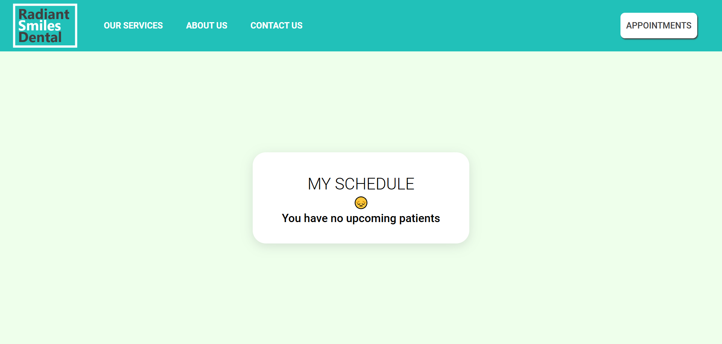

Figure : Image of appointments_doctor_view.php (Case of 0 appointments)

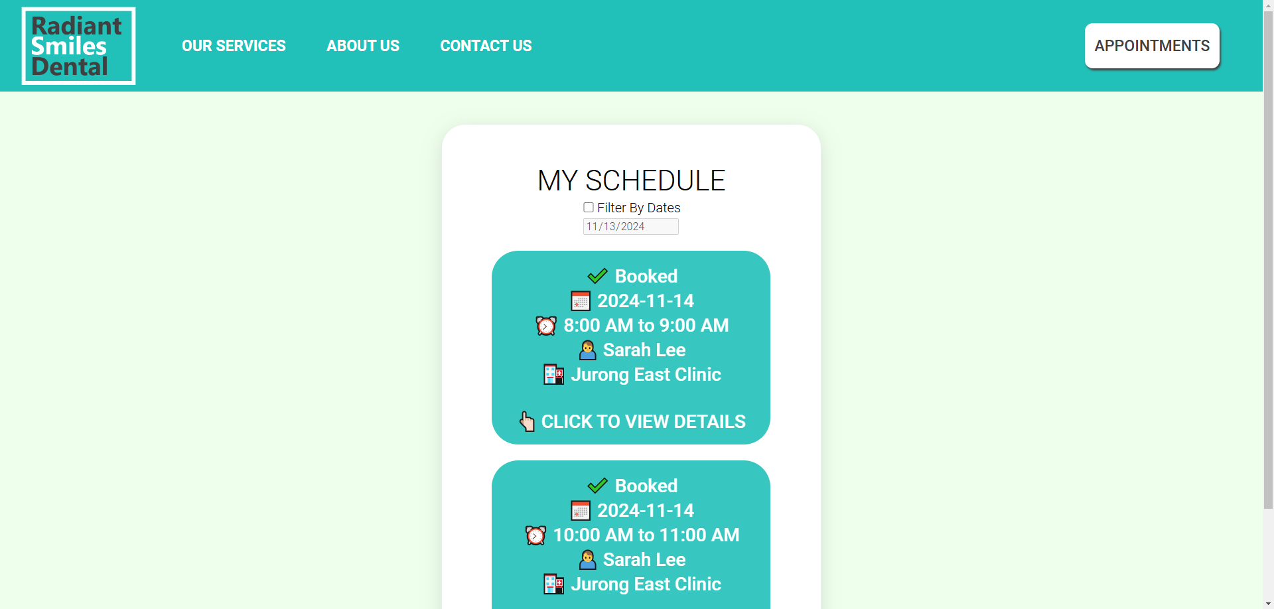

Figure : Image of appointments_doctor_view.php (Case of 1 or more appointments)

The page is rather similar to appointments_client_view.php except that instead of displaying the doctor’s name, we display the patient’s name for the doctor to see. An additional feature compared to appointments_client_view.php is that we also allow the doctor to filter the schedule show by dates, to enable filtering by date the doctor can check the checkbox ‘filter by dates’. When filtered by dates, the page will only show the appointments on the chosen dates. We achieve this by first querying all appointment slots associated with the doctor from the appointmentslots table, we set each of these appointments as buttons with the class set as booked and appointmentdate. When the filter is turned on and date is set, the classes which match the date set are shown and those that do not match are not shown, this is achieved by using javascript to modify the hidden attribute.

The above discusses the case where the doctor has at least one appointment, if the doctor has no appointments, a message ‘You have no upcoming messages’ is displayed instead.

**4.2.2.2.4 apptdetailsdr.php**

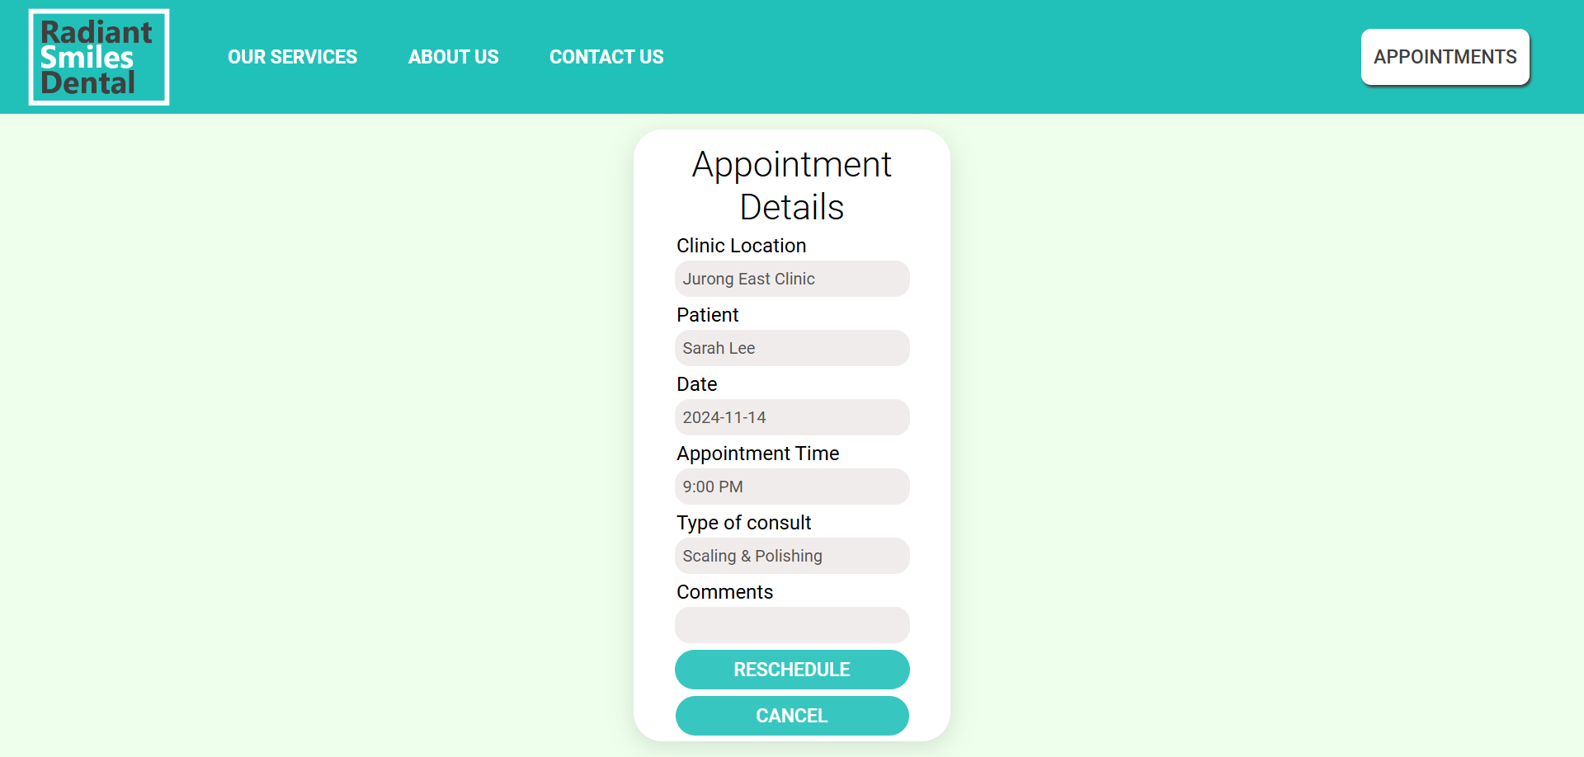

Figure : Image of apptdetailsdr.php

This page functions exactly the same as apptdetails.php except that instead of displaying the doctor’s name, it displays the patient's name for the doctor to view.

The reschedule and cancel links to reschedule.php and cancel.php covered under the patient section.

**4.2.2.3 Admin**

**4.2.2.3.1 appointments.php**

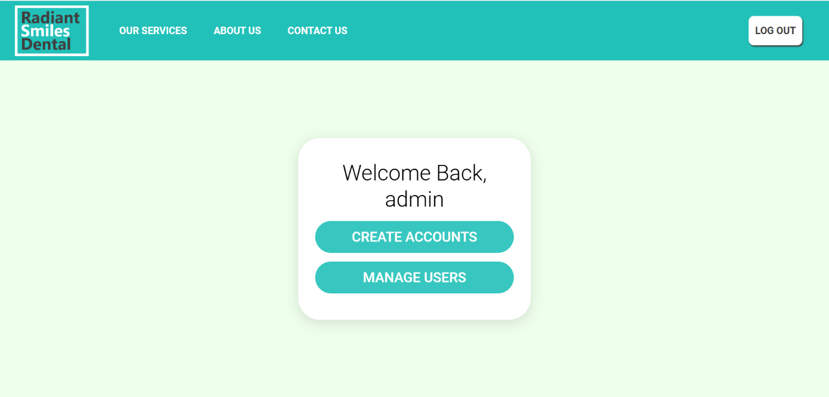

Figure : Image of the appointments.php (admin view)

This page is similar to the client view version as seen earlier. Except that the two a tags in the table are linked to create accounts page (adminreg.php) and manage users page (usermanagement.php).

**4.2.2.3.2 adminreg.php**

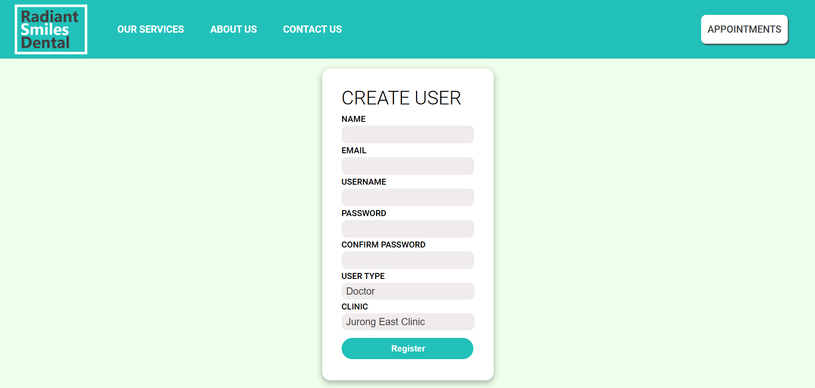

Figure : Image of adminreg.php

The page allows the admin to add any type of new user. There are 7 input fields. First, second third and fourth are fifth are text input fields, sixth and seventh are select inputs. The form validation is same as registration.php for the first 5 input fields (Name: Characters and spaces only, Email: 2-4 domains, username 5-15 characters & numbers, Password : minimum length 6 and can contain characters,numbers and special characters, password and confirm password must match . Fields cannot be empty). For the sixth field the admin can choose between patient, doctor and admin. If doctor is chosen the clinic field is enabled, the admin can choose which clinic the doctor is assigned to. If patient or admin user type is chosen, the clinic field is disabled and empty.

**4.2.2.3.2 adminreg_validation.php**

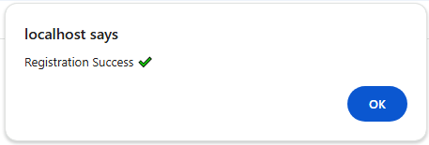

Figure: Image of alert (Case: successful registration)

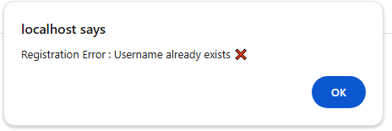

Figure: Image of alert (Case: failed registration)

adminreg_validation.php is a backend page which is not directly viewable to the user that is only available via the create user page (adminreg.php), the purpose of the page is to register a user using values set by an admin. Using post variable passed via adminreg.php we check if the username already exists, if username exists we set $_SESSION['adminreg_username_exists'] = true; and redirect to appointments.php where an alert will show “Registration Error: Username already exists” . If username does not exist, we insert the post variables from adminreg.php into users table, then we set $_SESSION['adminreg_success'] = true and redirect to appointments.php where an alert will show “Registration Success”.

**4.2.2.3.3 usermanagement.php**

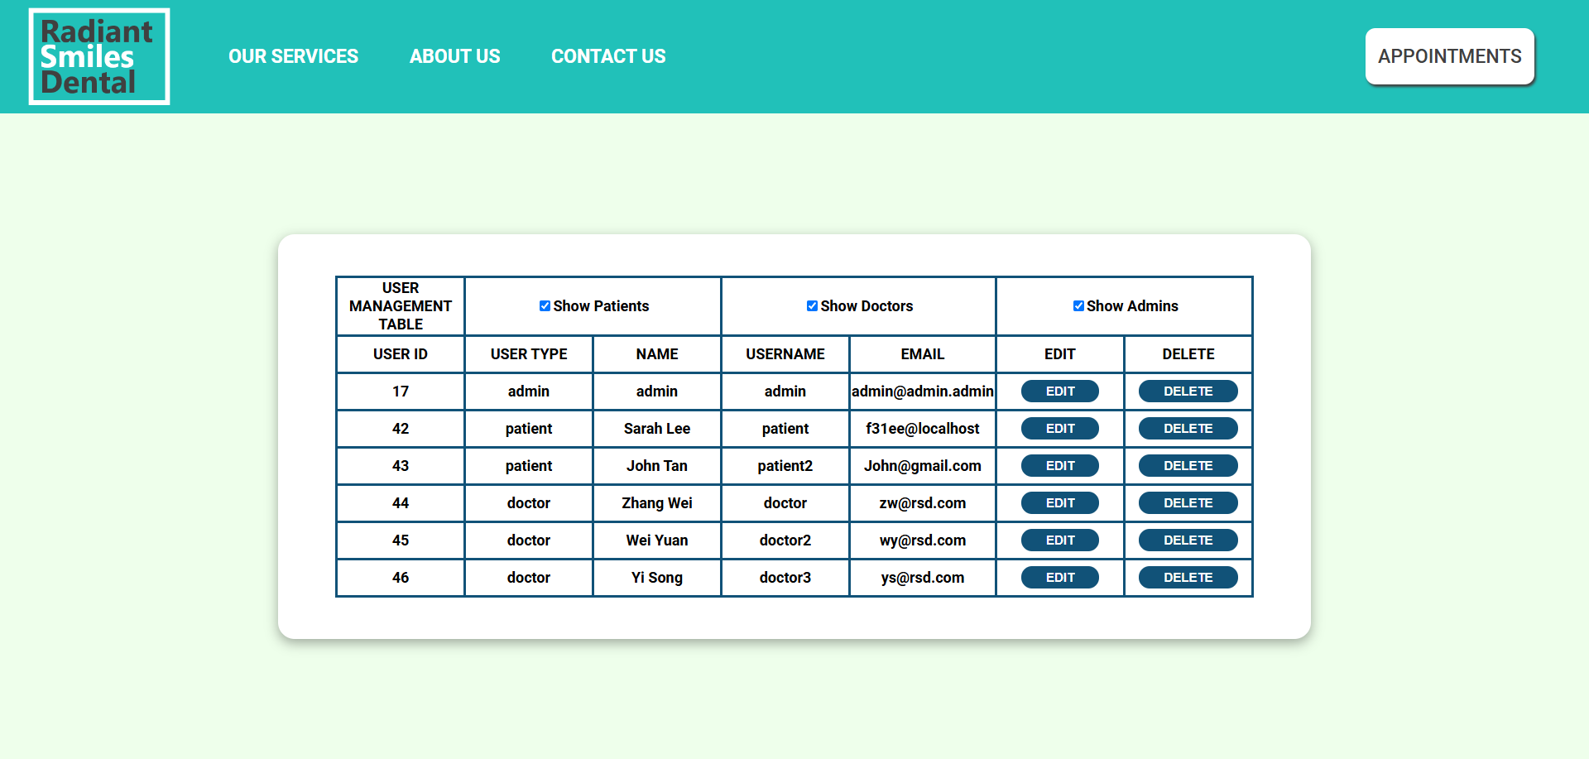

Figure : Image of usermanagement.php

The page first queries all rows from the users table, and displays each row as a row in the table in the table in the div, we also include the option to edit and delete each user’s details. There is also an option to filter the table to only show patients, doctors and admins. To achieve the above features, we use form for each edit and delete button and set a hidden input in each form with the user_id as value and ‘link’ as name and form action useredit.php and deleteuser.php respectively. To achieve the filter system, during the first query and setting each table row we set the class of each row to user_type. When the show patients checkbox is checked, table rows with the class patient is set to visible, otherwise, it is hidden. When the show doctor checkbox is checked, table rows with the class doctor is set to visible, otherwise, it is hidden. When the show admin checkbox is checked, table rows with the class admin is set to visible, otherwise, it is hidden. This page allows the admin to have a quick overview of all users as well as allow them to edit and delete the details of each user.

**4.2.2.3.4 useredit.php**

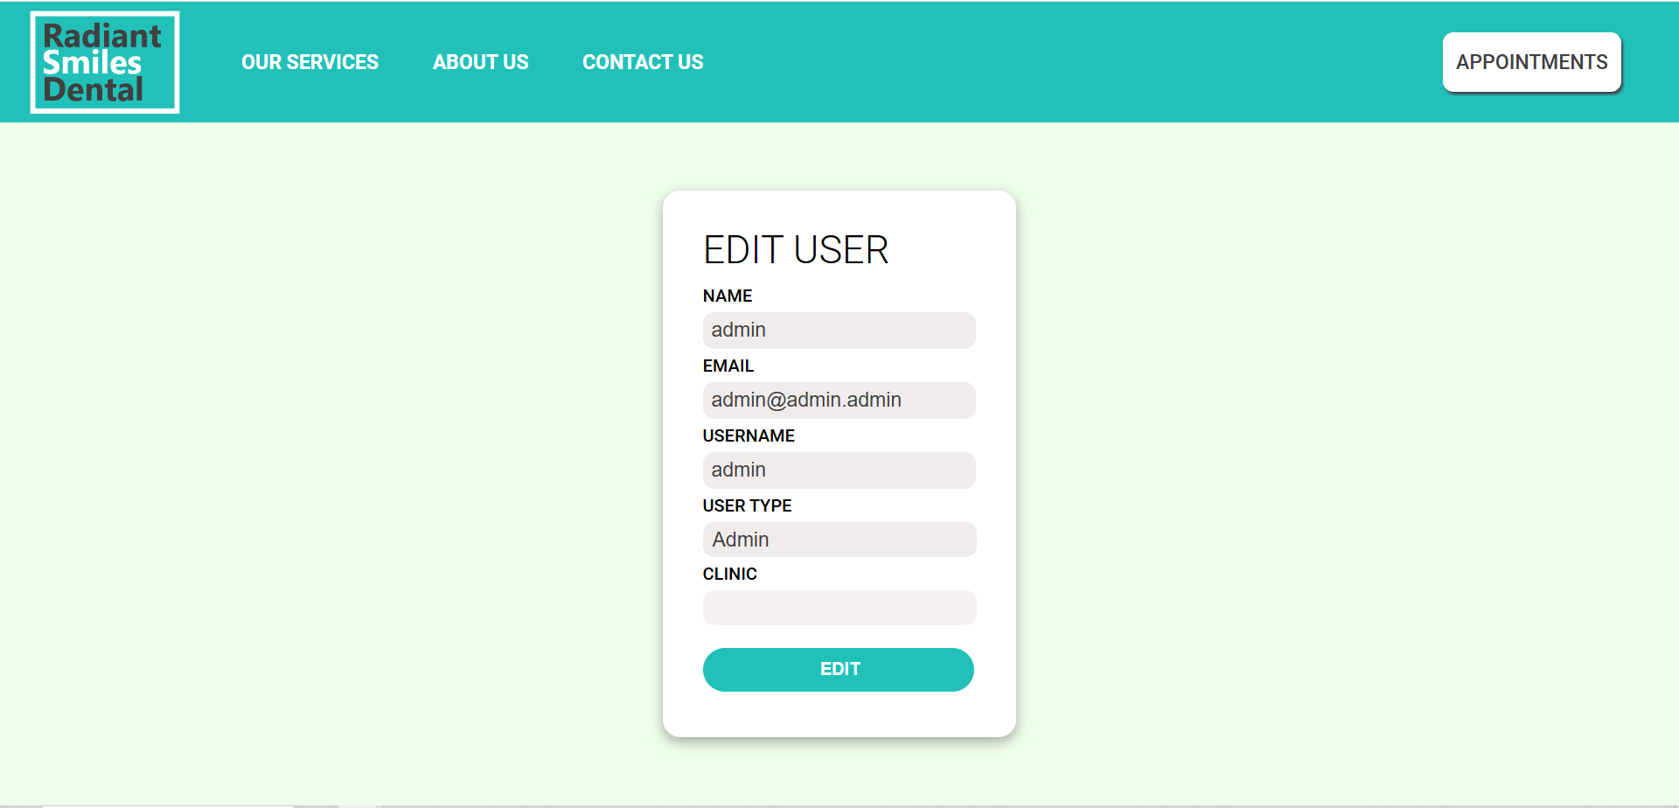

Figure : Image of edituser.php

This page is very similar to adminreg.php except that there is no password and confirm password due to security. Changing of passwords can be done for users via resetpassword.php , another difference is that the user’s data is preloaded into each field, this is done by using $POST[‘link’] which represents user_id from usermanagement.php to query the users table for the data. When edit is clicked, the user is directed to admineditvalidation.php

**4.2.2.3.5 delete.php**

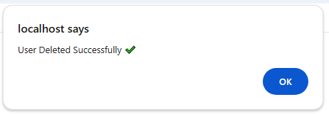

Figure : Image of user deletion (Case : success)

delete.php is a backend page which is not directly viewable to the user that is only available via the user management page (usermanagement.php), the purpose is to delete the user. The $POST[‘link’] which represents user_id from usermanagement.php is used to delete the specific user from users table. On successful deletion, we set  $_SESSION['delete_user'] = true; and redirect to appointments.php where an alert is shown for successful deletion.

**4.2.2.3.5 admineditvalidation.php**

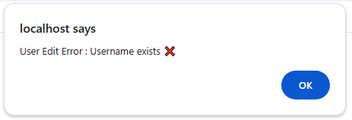

Figure : Image of alert (Case : User edit error)

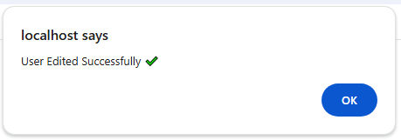

Figure : Image of alert (Case : User edit successful)

admineditvalidation.php is a backend page which is not directly viewable to the user that is only available via the user edit page (useredit.php), the purpose is to update the details of the user in the users table. First we check if the username from useredit.php is the same as the user’s existing username, if it is a new username, we check if the new username matches with any existing username, if there is a match we set $_SESSION['adminedit_username_exists'] = true; and redirect to appointments.php where an alert will display “User Edit Error : Username exists”. If there is no match, we check if user_type is set to doctor or patient. If user_type is doctor, we insert the details into users table, then we query to see if the user was previously listed as a doctor, if the user is not previously listed as a doctor we insert the details into the locations table, if the user is previously listed as a doctor we update their existing details in the locations table. Then we delete any appointmentslots they had if they were previously listed as a patient. Then, we set $_SESSION['adminedit_success'] = true; and redirect to appointments.php where an alert will display “User Edited Successfully”. If user_type was set as patient or admin, we update their details in the user tables and delete their associated information from locations and appointmentslot table if they were previously listed as a doctor. Then, we set $_SESSION['adminedit_success'] = true; and redirect to appointments.php where an alert will display “User Edited Successfully”.